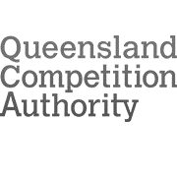

Annual report 2020–21

© Queensland Competition Authority 2021
The Queensland Competition Authority supports and encourages the dissemination and exchange of information.
However, copyright protects this document.
The Queensland Competition Authority has no objection to this material being reproduced, made available online
or electronically but only if it is recognised as the owner of the copyright and this material remains unaltered.

Content

Highlights 1
About us 2
Economic context 2
Our board 4
Senior staff 5
Chair’s introduction 8
CEO’s message 9
Projects in 2020–21 11
Retail electricity prices 2020–21: supplementary tariffs 12
Retail electricity prices 2021–22 12
Schedule 8 review (Electricity Regulation 2006) 12
SEQ electricity market monitoring 12
Seqwater bulk water pricing 2022–26 13
Access undertakings 13
Product development 15
Ongoing regulatory work 16
Corporate matters 17
Corporate governance 18
Projects undertaken in 2020–21 22
Our people and workforce profile 28
Our publications 32
Publications released and submissions received 32
Financial statements 37
Statement of comprehensive income 39
Statement of financial position 40
Statement of changes in equity 41
Statement of cash flows 42
Notes to and forming part of the financial statements 43
Certificate of Queensland Competition Authority 53
Independent auditor’s report 54
Glossary 57
Appendices 58
Appendix A: Letter of compliance 59
Appendix B: Compliance checklist 60
Annual report access 62

Highlights
The body of work we completed this year includes:

- a final determination on supplementary regulated retail electricity tariffs and prices for 2020–21 in regional Queensland (page 12)

- a final determination on regulated retail electricity prices for 2021–22 in regional Queensland (page 12)

- advice to the Minister for Energy on Schedule 8 of the Electricity Regulation 2006 (page 12)

- an annual market monitoring report of the SEQ retail electricity market (page 12)

- a final determination on solar feed-in tariffs for 2021–22 for regional Queensland (page 16)

- a final decision on the Dalrymple Bay Coal Terminal 2019 draft access undertaking, including an arbitration guideline (page 13)

- a final statement on water pricing principles (page 15)

- an issues paper on the inflation forecasting review (page 15)

- a draft report on the rate of return review (page 15)

- an external declaration guide (page 15)

- a decision on Aurizon Network’s maintenance and cross-system voting draft amending access undertaking (DAAU) (page 16)

- a decision on Aurizon Network’s Meteor Downs South pricing DAAU (page 16).

About us

The Queensland Competition Authority (QCA) is an independent statutory body, established in 1997.
Our primary role is to ensure monopoly businesses operating in Queensland, particularly in the provision of key infrastructure, do not abuse their market power through unfair pricing or restrictive access arrangements.

Economic context
We regulate the market behaviour of a number of monopoly businesses in Queensland.
In a competitive market, a business is constrained by its competitors in the prices it can charge for goods or services. If too high a price is charged, consumers are likely to buy from a competitor at a lower price. Alternatively, if the business is the only supplier and charges too high a price, a competitor will likely enter the market offering a lower, but still profitable, price.
However, it is not always possible or sensible to have competition in industries that require large-scale infrastructure investment, including many essential services. This is because there may only be one possible supplier (e.g. there may be only one possible site for a dam) or it may not be economic to have more than one supplier (e.g. the costs of constructing a new electricity distribution system would simply outweigh the benefits from having competing networks).
In these cases, there may be limited, if any, competitive forces to constrain the behaviour of the business, especially in the provision of energy, transportation or water.
Our role is to prevent the abuse of market power that may arise from a lack of competition.

Responsibilities
The Queensland Competition Authority Act 1997 (the QCA Act) is the legislation that guides our work.

Monopoly prices oversight
We use pricing and other regulatory arrangements, based on sound economic and commercial principles, to encourage monopoly businesses to operate responsibly in the absence of normal competitive market forces.
Prices oversight prevents monopoly businesses from abusing their market power by charging excessive prices for their products or services.
Where we oversee monopoly prices, consumers can be confident they are paying reasonable prices, while businesses can still earn a reasonable investment return—a beneficial outcome for all.
We may investigate the pricing practices of such monopolies or monitor their pricing practices, depending on the referral from the Treasurer. We only perform these functions on request from the Treasurer.

Third party access
Essential infrastructure that underpins economic activity should be accessible to all potential users.
We regulate third party access to essential infrastructure so as to support competition, by enabling competitors (i.e. ‘third parties’) to access infrastructure which cannot be economically duplicated, such as rail tracks and ports. For example, in the Queensland rail sector, we ensure track operated by Aurizon Holdings may be used by other train operators. This provides customers, such as coal miners, with options regarding the haulage of their product.
By opening up access, competition in related markets may be enhanced.

Competitive neutrality
As of 2 June 2021, we are handling competitive neutrality matters related to relevant state and government businesses.
We advise government agencies about complying with the principle of competitive neutrality. We also receive, investigate and report on complaints about the alleged failures of government agencies to comply with the principle of competitive neutrality.
Competitive neutrality is the principle that a public sector business or agency should not have a competitive advantage (or disadvantage) over the private sector solely due to being government-owned. Public sector businesses should compete with private sector businesses on an equal (competitively neutral) basis.
Ways in which public sector businesses can have competitive neutrality advantages over private sector businesses include:
- be exempt from taxes and charges
- have access to less expensive funds because of implicit or explicit government guarantees
- be exempt from complying with certain regulations and procedures.

General issues
Apart from the specific responsibilities outlined above, we have a range of general responsibilities. In particular, under section 10(e) of the QCA Act, Ministers can direct us to investigate and report on matters relating to competition and industry.

Responsibilities outside the QCA Act
Our responsibilities, in addition to those under
the QCA Act, include:
- setting regulated retail electricity prices under the Electricity Act 1994 (the Electricity Act) for regional Queensland
- enforcing customer protections under the Electricity Distribution Network Code and the Gas Distribution Network Code.

Industry
During the course of our work, we work with stakeholders in the electricity, water, rail, ports and gas industries.

Our board
Our board comprises four members, who
are appointed by the Governor in Council, in accordance with the QCA Act. In appointing members, regard is given to their collective knowledge and understanding of commerce, economics, the responsibilities of the QCA, and the interests of consumers and other stakeholders. Board members are appointed for a term of not more than five years.

Chair

Professor Flavio Menezes
Appointment: April 2016–December 2021
Flavio is a Professor of Economics at The University of Queensland. He is a former president of the Economic Society of Australia (Queensland), was a member of the advisory board of the federal government’s Deregulation Taskforce and was an elected member of the University of Queensland Academic Board and its Standing Committee. Professor Menezes is a fellow of the Academy of the Social Sciences in Australia, a member of editorial boards, associate editor of a number of international journals and a co-editor of the Economic Record journal. He has published extensively on the economics of auctions, competition and regulatory economics, industrial organisation and market design.
Professor Menezes has extensive consulting experience. His experience in Australia includes advising the federal government, the AEMC, the ACCC, IPART, the QCA, and the ACT and Victorian governments on market design issues in regulatory environments. He has also provided economic advice to various private and public organisations on competition and regulatory issues in defence, fisheries, gambling, energy, banking, health, aged care, disability care, transport, ports, water and telecommunications.

Deputy Chair

Madeline Brennan QC
Appointment: April 2016–December 2021
Madeline is a barrister with 25 years’ experience as a member of the Queensland bar, as junior counsel (3 June 1996–2015) and senior counsel (November 2015). In 2000, she was a founding member of Roma Mitchell Chambers in Brisbane.
Madeline has had a broad practice, inclusive of consumer protection law, general civil litigation, general administrative law and family law. Madeline’s practice currently includes appellate and trial advocacy and advisory work specialising in the areas of administrative law, and taxation and revenue law. Madeline has been involved in significant judicial review litigation (including mineral royalty disputes, review of decisions under the Environmental Protection Biodiversity Act (Cth)), and in merits review of a broad range of Queensland state and federal government decisions.
Madeline has served on school, hospital and professional committees and boards. She served for eight years on the Human Research Ethics Committee of the Queensland Institute of Medical Research before her appointment to the QCA in 2016.

Member

Dr Warren Mundy FAICD FRAeS
Appointment: June 2018–September 2024
Warren is the managing director of Bluestone Consulting, which has been providing advice to investors, regulators, providers, and users of a wide range of infrastructure services since 2003.
He was a commissioner at the Australian Productivity Commission from 2009 to 2015 and also served as the Australian Competitive Neutrality Commissioner. He has held executive roles in airport companies in Australia and Europe.
At Airservices Australia, he served on the board for more than five years from 2008, including being the deputy chair for over four years. He was also a member of the Steering Committee for the joint NSW and Commonwealth governments’ Sydney Aviation Strategy and continued to advise the Australian Government on Sydney’s second airport until the creation of the company to build the airport. Other roles were as a director of VicForests, the Western Community Legal Centre, the National Health Co-operative, James Watt College of Higher and Further Education, and the Airports Operators Association (United Kingdom).
Dr Mundy is currently chair of the Energy Industries Superannuation Scheme and a director of the Sydney Desalination Plant and of TransGrid.

Member

Fiona Guthrie AM
Appointment: January 2019–December 2021
Fiona is currently the chief executive of Financial Counselling Australia. Financial counsellors provide advice and support to people with money and debt problems.
Fiona has 30 years' experience in consumer advocacy, including a number of years on the executive of the Consumers Federation of Australia. She first became involved in issues affecting consumers, particularly people on low incomes or in vulnerable circumstances, after volunteering as a financial counsellor at Caxton Legal Centre in Brisbane in 1989.
She has held directorships on Energex Retail, the Insurance Ombudsman Service and the Financial Ombudsman Service and was previously chair of ASIC’s Consumer Advisory Panel.
Fiona is currently a member of the ACCC's Consumer Consultative Committee and a member of the board of both Way Forward Debt Solutions and Choice.
She was a recipient of an Order of Australia in the 2017 Queen's Birthday honours for significant service to the community through social welfare and financial counselling roles.

Senior staff

Chief Executive Officer

Charles Millsteed
Charles rejoined the QCA in 2010.
He commenced as CEO in September 2016 after various roles in senior management, including during a period of significant change for the QCA.
Charles has broad experience in policy analysis and economic regulation. He commenced his career at the Australian Bureau of Agricultural and Resource Economics, focusing on energy market analysis and assessing the impact of trade, investment and climate change policies.
Since 2001, Charles worked in economic regulation in various roles at the QCA, Ergon Energy and the Australian Energy Regulator.

Director—Business Performance

George Passmore

George joined the QCA in 2000.

George has over 20 years’ experience in economic regulation.

His role involves managing the QCA’s ongoing regulatory roles in compliance and monitoring of the performance of businesses regulated by the QCA. Before that, George was extensively involved in the economic oversight of water and local government sectors, as well as rail access regulation in the QCA.

George started his career with the Bureau of Agricultural Economics before moving to Queensland and working on sugar industry policy, water sector policy and Queensland’s first review of irrigation water price paths.

Director—Peer Review

William Copeman
William joined the QCA in 2010.
William’s diverse experience encompasses roles at Queensland Treasury, Queensland Treasury Corporation and Deloitte Economics.
His primary role is to provide assurance of the diverse technical analysis undertaken for the QCA. He also oversees product development and technical staff-development initiatives.
He has delivered economic regulation, analysis and policy development in both the public and private sector. In particular, William has worked extensively in the Queensland water industry.

Director—Corporate Services

Ray Rapinette
Ray Rapinette joined the QCA in 2016.
Ray has many years of experience in senior and executive roles in banking, local government and Queensland statutory bodies.
During the year Ray was on leave and temporarily replaced by Sharon Ibardolaza.

Director—Corporate Services

Sharon Ibardolaza
Sharon joined the QCA in October 2020.
Sharon brings with her extensive experience in senior and executive roles in the tourism, banking and local government industries.
Her role involves managing the provision of a range of corporate services, including governance, financial management, information technology, human resources and corporate administration.
Sharon’s previous roles include business strategy development, risk management, corporate and operational planning, cultural change management and leading and managing multi-disciplinary teams to deliver major projects.

Organisational chart as at 30 June 2021

Government bodies 2020–21
Name of Government body: Queensland Competition Authority Board
Act or instrument | Queensland Competition Authority Act 1997
Functions | Our primary role is to ensure monopoly businesses operating in Queensland, particularly in the provision of key infrastructure, do not abuse their market power through unfair pricing or restrictive access arrangements.  We achieve this through investigating and monitoring pricing practices of certain monopoly businesses and regulating third party access to essential infrastructure such as railways and port channels.  As of 2 June 2021, we have also assumed responsibility for dealing with competitive neutrality matters.
Achievements | Refer to pages 12–35 of this annual report.
Financial reporting | Financial transactions of the QCA are accounted for annually in the audited Financial Statements
Remuneration
Position | Name | Meetings/sessions attendance | Approved annual, sessional or daily fee | Approved sub-committee fees if applicable | Actual fees received
Chair | Professor Flavio Menezes | 25 | $150,000 p.a. | 0 | $150,061
Deputy Chair | Madeline Brennan QC | 25 | $75,000 p.a. | 0 | $75,030
Member | Dr Warren Mundy FAICD FRAeS | 24 | $75,000 p.a. | 0 | $75,030
Member | Fiona Guthrie AM | 25 | $75,000 p.a. | 0 | $75,030
No. of scheduled meetings/sessions | 25
Total out of pocket expenses | $419,607

Chair’s introduction
Amid continuing covid-19 impacts, we had a busy year monitoring and setting electricity prices and enforcing regulatory compliance by electricity retailers and distributors. We also finalised a more light-handed set of regulatory arrangements for access to Dalrymple Bay Coal Terminal and consulted with stakeholders on guidance material for a range of matters, which will prove useful over the coming years.

Electricity industry developments
Covid-19 impacts on households and businesses during 2020–21 emphasised the importance of our roles in the electricity industry. Our monitoring of the retail electricity market in south east Queensland revealed continued price decreases and innovative product offerings available for customers who shopped around. In regional Queensland, electricity prices fell again, and ongoing developments in the electricity industry saw us set a range of new tariffs under delegation by the Minister for Energy.
While prices have been falling across Queensland, we have remained vigilant in relation to the compliance of electricity retail and network businesses with their legislative obligations, and implemented several enforcement actions to uphold customer protections.

Lighter-handed regulation for Dalrymple Bay Coal Terminal
During the year, we finalised an access undertaking for Dalrymple Bay Coal Terminal (DBCT) that came into effect on 1 July 2021. Unlike previous undertakings, the new undertaking does not include reference prices. Instead, it provides for prices to be agreed by commercial negotiation, with recourse to arbitration by the QCA where agreement is not reached. This represents a reframing of the negotiate-arbitrate process under the QCA Act, placing greater emphasis on negotiations. Importantly, the exercise of market power will be constrained by the ability of parties to refer a dispute to us for arbitration, and by a range of information disclosure and other provisions we required to be included in the undertaking.

Guidance for stakeholders
It is important for our work to be transparent and predictable, so that stakeholders can have confidence in our decision making and benefit from lower regulatory costs. With these aims in mind, we consulted with stakeholders on a range of matters during 2020–21, including the rate of return for regulated businesses and our approach to estimating expected inflation. We also revised the pricing principles that guide us when we make recommendations to the Queensland Government about prices for monopoly water services. Finally, we published an arbitration guideline that explains how we intend to manage a dispute in relation to the DBCT service, as well as a guide to declaration of services under the QCA Act.

Competitive neutrality
On 2 June 2021, we regained responsibility for competitive neutrality matters in Queensland. Competitive neutrality is the principle that a government organisation should not have an advantage over the private sector due to their government ownership. We will provide advice about competitive neutrality and will investigate complaints about alleged failures to comply.
In closing, I would like to thank staff and my fellow board members for their hard work and flexibility in fulfilling our statutory obligations during what has been another challenging year.

Chair
Professor Flavio Menezes

CEO’s message
The range of measures we implemented at the onset of covid-19 remained in place during 2020–21, allowing staff to remain productive, healthy and safe.

Staying safe and productive
Our Work Health and Safety Plan for Covid-19 was adjusted throughout the year to ensure continuing compliance with updated Queensland government advice, including the social distancing and hygiene measures recommended to reduce the risk of transmission. Meetings, workshops and other discussions were conducted via video- and teleconferencing, and staff continued to benefit from the range of established programs that support their physical and mental health.
Recognising the importance of staff engagement and collaboration for our productivity and culture, we implemented various measures to support staff networks and collaboration as they continue to balance working from home and the office, including a wide variety of in-house activities and social events.

Staff development
A key strength of our project-based approach to work is that staff gain experience and knowledge across a range of industries and subject matters. The capability and flexibility this approach produces allows us to meet our statutory obligations effectively and efficiently. During 2020–21, staff capability was further enhanced by staff participation in a range of internal and external training and development activities. These included a regulatory training course provided by Australian regulators (including the QCA), external work placements, post-graduate university studies, and a number of technical and professional development seminars provided in-house and by external providers.
Ongoing covid-19 impacts made industry visits by QCA board members and staff more difficult to arrange during 2020–21, but we are hopeful of recommencing visits soon, starting with our next review of Seqwater's pricing, which commenced on 18 June 2021.

Corporate governance and financial position
We remain committed to the highest standards of corporate governance. During the year we reviewed and re-set our strategy for the next four years. Our vision and purpose are to improve the prosperity of Queenslanders by making Queensland’s economy more competitive through efficient and effective economic regulation. The plan includes detailed objectives and goals that provide staff with concrete guidance for their work.
We also reviewed a range of corporate policies, including those related to managing risk, information and intellectual property, of particular importance given the ongoing spread of work across the office and home.
On the financial front, we reported a loss of $0.9 million for 2020–21, better than the budgeted loss of $1.8 million. This resulted from $0.3 million more revenue than budgeted and $0.6 million less expenditure. The lower-than-expected loss was funded by our reserve.

Our performance
A snapshot of our performance results for 2020–21 shows that, overall, relevant key performance targets were achieved. Where we did not meet our performance targets, it was mainly due to the ongoing challenges in delivering workshops and meetings in the current environment.
I would like to close by thanking staff for their professionalism and resilience during 2020–21, as the impacts of covid-19 endure for longer than we might have hoped at the start of the year. Staff have not only maintained high quality and timely work, they have seized opportunities for training and development, which sets us up well for coming years. I would also like to thank our board members for their expertise and constructive support and guidance over the past year.

Chief Executive Officer
Charles Millsteed

Projects in 2020–21

Overview

The QCA’s role involves:
- determining and recommending prices
- monitoring prices and services
- overseeing access regulation.
Our vision is to improve the prosperity of Queenslanders, and our purpose is to make Queensland’s economy more competitive through efficient and effective economic regulation.
We conduct all our investigations and reviews in line with the four objectives of our strategic plan:
- Optimise regulatory frameworks.
- Make unbiased, transparent and robust decisions.
- Promote understanding and engagement.
- Enable efficient, flexible and expert resourcing.
We contribute to the Queensland Government’s objectives of growing our regions, building Queensland and supporting jobs.

Retail electricity prices 2020–21: supplementary tariffs
On 24 June 2020, we received a delegation from the Minister for Natural Resources, Mines and Energy to set three new electricity (load control) retail tariffs for 2020–21. The new tariffs applied from 1 November 2020 and supplemented the existing suite of regulated tariffs for customers in regional Queensland in 2020–21.
On 29 June 2020, we published a stakeholder notice with further information, including an initial consultation timetable with key project milestones.
On 3 August 2020, we received a delegation from the Minister to set eight additional retail tariffs for 2020–21. The new tariffs applied from 1 January 2021 and supplemented the existing suite of tariffs for 2020–21.
Given the timeframes, we combined the review of the new load control tariffs with the review to set eight additional retail tariffs.
On 25 August 2020, we published our draft determination on the supplementary tariffs for 2020–21. We received four submissions in response to the draft determination.
On 16 October 2020, we published our final determination, introducing the following tariffs:
- three new load control tariffs (which commenced on 1 November 2020)
- eight additional retail tariffs (which commenced on 1 January 2021).

Retail electricity prices 2021–22
In January 2021, we received a delegation from the Minister for Energy, Renewables and Hydrogen to set retail electricity prices to apply in regional Queensland in 2021–22.
As part of the review, we published:
- an interim consultation paper in January 2021, in which we invited stakeholders to comment on key issues. We received six stakeholder submissions in response (including one confidential submission)
- a draft determination in March 2021, in which we invited stakeholders to comment, including on the draft prices. We received seven stakeholder submissions in response
- a final determination in June 2021, providing final prices to apply from 1 July 2021.
We also held a virtual workshop after publishing the draft determination, to assist stakeholders in preparing submissions.
Overall, the final prices result in lower electricity costs for consumers in regional Queensland. A typical customer on the main residential tariff will see a decrease of 7.3%, and a typical customer on the main small business tariff will see a decrease of 3.7%. The fall in residential and small business prices is largely due to a decline in estimated energy costs.

Schedule 8 review (Electricity Regulation 2006)
In mid-2020, we received a direction from the Minister for Natural Resources, Mines and Energy to undertake a review of Schedule 8 of the Electricity Regulation 2006.
Schedule 8 sets maximum prices that customers can pay for certain services, including special meter reads undertaken by Energex and Ergon Energy and some disconnections and reconnections of electricity supply.
We provided our written advice to the Minister by 12 February 2021.

SEQ electricity market monitoring
The Queensland Government deregulated retail electricity prices for residential and small business customers in south east Queensland (SEQ), effective from 1 July 2016. The market monitoring and reporting function in section 89B of the Electricity Act is a light-handed framework under which the government can monitor the operation of the SEQ retail electricity market to ensure customers can benefit from price deregulation and increased competition in SEQ.
In April 2020, the Minister for Natural Resources, Mines and Energy directed us to monitor and report on the operation of the SEQ retail electricity market for residential and small business customers from 1 July 2019 to 30 June 2020.
The annual report for 2019–20 (released in December 2020) found that in 2019–20, 31 retailers in SEQ had offers available for residential and small business customers. For most retailers, their cheapest market offer in the June quarter of 2020 was lower than their cheapest offer available a year earlier. Standing offers for both residential customers and small business customers became substantially cheaper too, following the introduction of the default market offer on 1 July 2019.
Retailers also offered new innovative products such as subscription electricity plans that are similar to prepaid mobile plans, plans that integrate supply from the grid and solar PV with battery storage, plans that pass through all costs to customers, and plans for owners of electric vehicles.
The report concluded that customers had many opportunities to benefit from competition in the SEQ market in 2019–20.

Seqwater bulk water pricing 2022–26
On 16 June 2021, the Treasurer directed us to investigate Seqwater’s bulk water pricing practices.
The objective of the investigation is to recommend bulk water prices to apply from 1 July 2022 to 30 June 2026.
We must provide a draft report by 30 November 2021 and a final report by 31 March 2022.

Access undertakings
We have an active role in administrating access undertakings of the three businesses subject to the access regime contained in the QCA Act.
Access undertakings for Queensland Rail and Aurizon Network are in place until 2025 and 2027 respectively. This year we approved the 2019 DBCT draft access undertaking (DAU), which became the 2021 DBCT access undertaking on 1 July 2021.

Dalrymple Bay Coal Terminal (DBCT)
DBCT is a coal export terminal located in central Queensland, approximately 40 kilometres south of Mackay. DBCT is the only port facility that has been declared under Part 5 of the QCA Act.
While the Queensland Government owns DBCT, the terminal is leased to Dalrymple Bay Infrastructure Management Pty Ltd (DBIM). DBIM has a 50-year lease over the terminal from 2001, with an option to extend the lease for a further 49 years.
During 2020–21, DBIM provided access to the terminal under the terms and conditions set out in its 2017 access undertaking, which we approved in February 2017.
On 1 July 2019, DBIM submitted a DAU, intended to take effect when the 2017 access undertaking notionally terminated on 1 July 2021.
In February 2020, we published an interim draft decision on the DAU pricing model, proposing to refuse to approve the pricing model. In our interim draft decision, we said that a pricing model without reference tariffs could be appropriate if the submitted model was amended considerably—but we noted that a pricing model with reference tariffs may provide some advantages over a pricing model without reference tariffs.
Our full draft decision (published in August 2020) was to refuse to approve the DAU. We proposed amendments we considered necessary for the DAU to be approved. We were of the view that a pricing model without reference tariffs could be appropriate to approve, provided amendments to the model in the DAU were made to better balance the arbitration and negotiation processes.
Following release of the draft decision, we held two further rounds of stakeholder consultation and received an additional seven submissions. We also held two public forums on the DAU—a general forum and a technical forum on the specific issue of remediation costs.
Our final decision in March 2021 was to refuse to approve the DAU. We provided DBIM with a secondary undertaking notice in our final decision, requesting an amended DAU that would be considered appropriate to approve. The final decision maintained the draft decision position that a pricing model without reference tariffs could be appropriate but that significant amendments to the DAU model as proposed were required to better balance the way the negotiation and arbitration processes will work.
On 12 May 2021, DBIM lodged an amended DAU. We assessed the amended DAU and determined that it complied with the notice. On 1 July 2021, we approved the DAU, which is now the 2021 DBCT access undertaking.

Queensland Rail
Queensland Rail is a statutory authority that provides passenger train services and operates a 6,600 kilometre rail network. The network includes south east Queensland commuter lines, the West Moreton system and the Mount Isa and North Coast lines.
On 1 July 2020, we approved the updated amended 2020 DAU, which is now Queensland Rail’s approved 2020 access undertaking that sets out the terms for access to its network. The new undertaking terminates on 30 June 2025.

Aurizon Network
Aurizon operates and manages Australia’s largest export coal rail network, the Central Queensland Coal Network (CQCN), through its subsidiary company Aurizon Network.
Aurizon Network’s 2017 access undertaking (UT5) sets out details of the terms on which it undertakes to provide access to the CQCN.
Aurizon Network’s 2017 access undertaking terminates on 30 June 2027.

Product development
We undertook the following projects as part of our product development initiative in 2020–21.

Review of regulatory pricing principles for the water sector
We maintain a set of regulatory pricing principles for the water sector. These principles were first developed in 2000 and guide us in assessing the level and structure of prices when making recommendations to the Queensland Government about pricing practices relating to monopoly water supply activities. They aim to promote economic efficiency and social equity in the supply and use of water and water supply infrastructure, consistent with our regulatory obligations.
We commenced a review of the principles in late 2020, releasing a draft statement for stakeholder comment in November 2020. We received 15 submissions on the draft statement.
We published a revised statement of principles on 23 April 2021. The revised statement represents a refinement of the previous principles. It sets out our contemporary decision-making processes when we undertake water pricing investigations.

Rate of return review
During the year we commenced a review into our approach to determining reasonable rates of return for entities that are subject to the regulatory regimes provided by the QCA Act. Our intention is that this process will promote confidence in our methods and provide stakeholders with transparency over our cost of capital approach.
In November 2020 we released a paper highlighting issues in focus for the review and requested comments from stakeholders. We received 16 submissions. In June 2021, we released our draft report. We expect to publish the final report later in 2021.
This process is not intended to prescribe a binding methodology for rate of return assessments, but rather to provide our latest consideration of these matters to guide stakeholders. Our intention is that in future regulatory reviews that require an assessment of rates of return, all stakeholders will be given an opportunity to make submissions, which we will consider on their merits.

Declaration for third party access
The third party access regime in Part 5 of the QCA Act provides a regulatory framework to enable access seekers to gain access to significant infrastructure services where there may be a lack of effective competition.
Under this regime, we consider requests for declaration and make a recommendation to the Treasurer on whether a service should be declared. If a service is declared, an access seeker is able to access the service on terms that are overseen by us. Requests for declaration must be in the form approved by us.
We published a declaration guide that provides information on our processes and broad guidance on the matters we must consider in making a recommendation to the Treasurer. We also published a form that provides high-level guidance on the matters an access seeker should address in making a request.

Inflation forecasting
Forecast inflation is used in our regulatory reviews to derive the investment returns that regulated entities receive, derive input price growth, and apply price smoothing to maintain prices in real terms. The treatment and estimation of inflation can have significant impacts on the revenues of regulated entities and the prices their customers pay.
We commenced a review of our inflation forecasting approach in early 2021, releasing an issues paper for stakeholder comment in March 2021. We received 7 submissions on this issue paper.
Our draft position paper, to be released in the second half of 2021, will give stakeholders the opportunity to comment before we release our final position paper later in 2021. Our final position paper will provide guidance to stakeholders on what we consider are the appropriate data sources and approach for estimating inflation in future regulatory reviews.

Ongoing regulatory work
The Business Performance team handles a range of ongoing economic regulatory work that falls outside the scope of individual projects. This includes monitoring compliance and performance, conducting capital expenditure reviews and tariff variation reviews, and dealing with stakeholder queries.
In 2020–21, Business Performance progressed a range of matters arising from access undertakings for Aurizon Network, DBIM (formerly known as DBCT Management) and Queensland Rail. The most notable amongst these matters are listed below.

Aurizon Network
- Endorsed variation events 2020–21: AT5 reference tariff and QCA levy
- Meteor Downs South Pricing draft amending access undertaking (DAAU)
- Capital expenditure claim 2019–20
- Maintenance and cross system voting DAAU
- Revenue adjustment amounts 2019–20
- Adjustment charges 2020–21
- Regulatory asset base roll-forward 2019–20
- Newlands maintenance strategy and budget
- Annual review of reference tariffs 2020–21

DBIM
- Proposed amendments to the DBCT terminal regulations
- DBIM’s application for a price ruling—the 8x expansion

Queensland Rail
- Capital expenditure claim 2019–20
Business Performance also managed the following (ongoing) projects in relation to energy:
- Monitoring the SEQ retail electricity market and providing an annual report (see page 12)
- Monitoring SEQ solar feed-in tariffs
- Setting the solar feed-in tariff for regional Queensland
- Monitoring compliance with the Electricity Distribution Network Code and derogations to the National Energy Customer Framework.

Corporate matters

Overview

Corporate governance
We continue to place great emphasis on corporate governance, including our robust and fact-based decision-making process. Our administrative framework is designed to support the delivery of effective and efficient economic regulation for Queensland.
We have a range of policies and procedures to help ensure that assets are safeguarded, proper financial and accounting records are maintained and the work and effort of staff are consistent with the board’s strategic direction.
We emphasise the management and protection of information, as well as the maintenance of confidentiality where appropriate. Our records are stored electronically, and paper records are retained as required. There were no breaches of information security during the financial year.

Audit functions
We have an established internal audit function. Due to being a small regulator, we outsourced our annual fee costing model and triennial internal control systems reviews.
This year, both reviews were undertaken by Grant Thornton, which found that our systems remain appropriate.
Finally, we received an unqualified audit certificate from the Queensland Audit Office for the reporting period—reflecting the effectiveness of the administrative framework.

Human rights
We acknowledge our obligations as a public entity under the Human Rights Act 2019 (HRA).
The HRA has as its objects the protection and promotion of human rights, to build a culture in the Queensland public sector that respects and promotes human rights, and to help promote a dialogue about the nature, meaning and scope of human rights.
During the year we:
- implemented human rights reviews in relation to all relevant decisions
- published a staff manual on HRA compliance
- arranged for employees to participate in a training course titled 'Public entities and the Queensland Human Rights Act 2019', which was conducted by the Human Rights Commission (26 employees took part)
- offered additional awareness training, delivered in-house by our senior legal officer
- published a human rights complaint guideline on our website.
No complaints were received about our conduct (under s. 58).

Corporate culture
We continue to explore innovative initiatives to support professional development that complement and extend the suite of training programs available to our staff. Our values (trust, respect, achievement, integrity and teamwork) underpin our culture. We have a values recognition scheme, which allows staff to be recognised for living our values.
All staff contracts include the requirement to abide by the code of conduct and to disclose any potential or actual conflicts of interest. Board members and staff absent themselves from all deliberations where conflicts of interest, real or perceived, are suspected or arise. This is further reinforced through awareness sessions and training.

Risk management
We monitor our major risks, including physical risks, employee practices liability, financial management risks, information management risks and reputation risks. We review the risk register quarterly to check mitigation and monitoring controls and activities. We also identify operational risks in our annual operation plan, which are reviewed half-yearly.
The board reviews all potential risks annually and maintains a watching brief over key and critical risks to ensure adequate mitigation and controls are effective.

Covid-19 response
We maintain a Work Health and Safety Plan for Covid-19, to ensure the ongoing health and safety of our staff. The implementation of this plan, and QCA working arrangements, were adjusted throughout the year to ensure continuing compliance with updated state government advice. During mandated lockdown periods, our normal operations were adjusted to accommodate staff working from home. Meetings and other discussions were conducted via video- and teleconferencing.

Policy and corporate documents
We routinely review and update our policies and guidelines. Policies reviewed or created during the reporting period include:
- Banned shares list
- Board meeting policy
- CEO and staff authorisations policy
- Fee framework
- Intellectual property policy
- Managing unreasonable behaviour from the public policy
- Purchasing policy
- Risk management policy
- Strategic plan
- Strategic workforce plan
- Allocation of project resourcing guideline
- Financeability assessment guideline
- IManage worksite user guide
- Intellectual property guideline
- KPI setting and evaluation guideline
- Complying with the Human Rights Act 2019 manual
- Information management manual
- Purchasing manual
- Risk management register
- Workplace Health and Safety manual.
All staff periodically receive awareness training and guidance on the application of policy requirements.

Financial performance
We reported a loss of $0.9 million for the 2020–21 financial year.
Our total revenue was $0.3 million higher than budgeted, largely due to higher than budgeted revenue from DBIM ($0.7 million) and energy price setting ($0.8 million). This was offset with decreased activity related to the projects for energy retail ($0.4 million), energy distribution ($0.1 million), Queensland Rail ($0.1 million) and Aurizon Network ($0.1 million), and a reduction in grant funding ($0.4 million). A number of minor variances account for the remaining difference of $0.1 million between budgeted and actual revenue.
Our total expenditure was $0.6 million lower than budgeted. Employee expenses ($0.6 million) and IT expenses ($0.1 million) were less than budget, and payments for specialist advice ($0.2 million) were over budget. A number of minor variances account for the remaining $0.1 million of under-spend relative to budget.
The favourable combined revenue and expenditure variances explains the improved financial position relative to the budgeted shortfall of $1.8 million.
Expenditure, including performance against budget, is reported monthly to the board.

Environmental statement
We maintain an environmentally friendly workplace. The Ann Street office has a 5.5-star NABERS energy rating and a 4-star NABERS water efficiency rating. We support the efficiency measures initiated by the building's management.
The office environment benefits from low sills and a stepped perimeter ceiling that maximises the natural light penetration and, together with motion-activated lighting, saves energy. We also promote recycling and we have in place recycling bins for paper and cardboard. The building facilities also support our policies on work–life balance, with excellent end-of-trip facilities (including secure bike racks and showering facilities) and heart-smart stairs between floors.

Open data
Statutory bodies are not required to maintain an open data strategy. However, we subscribe to open data principles and, unless deemed confidential or not required to publish by direction or legislation, we publish and provide access to information necessary to inform stakeholders. Information on the Queensland Government's open data policy is available on its Open Data Portal.

Consultancies
We use consultancies to augment our in-house capacity. When necessary, we utilise engineering firms and law firms to undertake work and activities and advise on specific requirements of a direction notice, or to comprehensively review and assess draft access undertakings and other submissions. We are mindful of the need to achieve value for money, and where possible, we use state government procurement standing offer arrangements or issue clearly specified tenders.

Overseas travel
There was no overseas travel during 2020–21.

Our performance framework
We established a performance framework, along with a set of key performance indicators (KPIs) in June 2018. The framework focuses on operational practices, rather than matters of policy or legislation. At the highest level, the framework reflects our commitment to innovate, manage costs, improve productivity and achieve practical outcomes.
Four themes underpin our performance objectives. They form the basis for the KPIs:
- effective and efficient regulatory outcomes
- timely and transparent processes
- efficient and reasonable costs and regulatory fees
- effective stakeholder engagement and communication.

Assessing our performance
An annual self-assessment and a biennial external review form part of our performance framework.
The self-assessment is an assessment of each project in our work program against all relevant KPIs. The assessment results are also peer-reviewed internally and are submitted to the QCA board for approval before they are published. All stakeholders are encouraged to provide feedback and comments following the publication of the annual assessment.
The first biennial review was conducted in July 2020. Various stakeholders were invited to participate, including entities regulated by us, customers of those entities, special interest and advocacy groups, our Consumer Advisory Committee and government representatives. The results were published on our website. The next review is scheduled for July 2022.

Performance results for 2020–21
A snapshot of our performance results for 2020–21 is shown below. Each of the 9 projects had a different set of circumstances and requirements. Some were guided by ministerial directions, others were statutory reviews and research and development projects. Therefore, not all KPIs applied to all of them.
Overall, relevant project key performance targets were achieved. Where we did not meet our performance targets, it was mainly due to the ongoing challenges with the global pandemic in delivering a series of regional workshops and meetings. This was overcome by using virtual meetings and workshops.

Performance assessment against KPIs, 2020–21
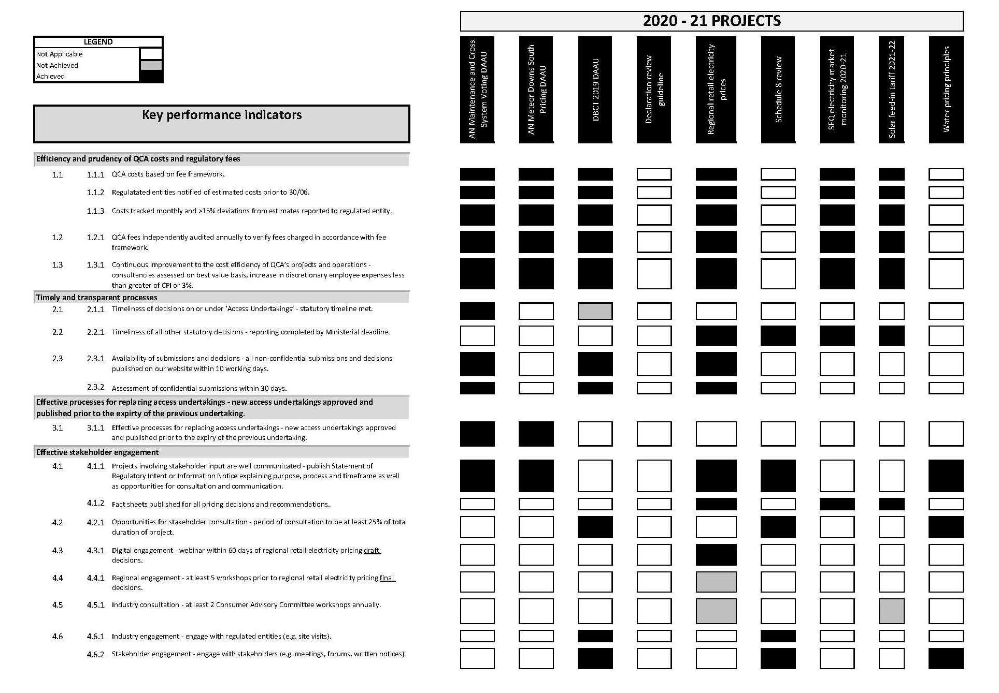

Projects undertaken in 2020–21
Further details regarding our project performance are included in the table below. This table expands on the figure above by giving more details about how each project performed against our KPIs. Information about the financial performance is not listed and is captured above.
Performance assessment by project, 2020–21
Project | Background | Status | Performance against KPIs
Aurizon Network’s Maintenance and Cross System Voting draft amending access undertaking (DAAU) | Aurizon Network proposed to amend the maintenance costs approval criteria in its access undertaking, including providing for voting rights to cross-system train services. | Completed | Timeliness and transparency: Aurizon Network submitted the Maintenance and Cross-system Voting DAAU in September 2020. We provided a final decision the following month, in October—under the QCA Act, we must endeavour to make a decision within six months. Before making our decision, we published the DAAU, invited submissions and considered the submissions we received, as required by the QCA Act. The speed of our decision can be attributed to the cooperation between all stakeholders, and our processes, which allow us to rapidly assess a DAAU and support a collaborative approach.  Stakeholder engagement: We provided time, as required under the QCA Act, for stakeholders to comment during our consultation process. We received a letter from the Queensland Resources Council (QRC) and Jellinbah Resources, acknowledging their support of the DAAU. Aurizon Network started the stakeholder engagement before submitting a formal DAAU.  Benefits/outcome: The proposal we approved allowed the maintenance and cross-system voting process to be streamlined and removed the ambiguity in the wording and clause reference. Additionally, the mutual agreement between all parties to the proposed changes before Aurizon Network’s formal DAAU submission allowed for a quicker decision-making process and a quicker turn-around in our deadlines, expedited the assessment of the DAAU and ultimately provided greater clarity for stakeholders much sooner.
Aurizon Network Meteor Downs South (MDS) Pricing DAAU | The Starlee expansion (an electrified passing loop on the Bauhinia branch line in the Blackwater system worth $8.6 million) has been constructed to accommodate the redevelopment of the Meteor Downs South (MDS) mine.  The MDS Pricing DAAU gives effect to a pricing proposal for the Starlee expansion. It proposes a new tariff and volumes for the Starlee expansion (with associated access conditions), corresponding revisions to the existing Blackwater system tariff and volumes, and consequential amendments to facilitate this approach.  The DAAU serves as a conduit for private infrastructure to be built (paid for by the mine) and for assets to augment the system owned by Aurizon Network. The assets will be included in its asset base. | Completed | Timeliness and transparency: The MDS Pricing DAAU and supporting documents were made available for stakeholders to comment on (August 2020). We also published and sought comments on our preliminary view (November 2020). Our final decision was published on our website for stakeholders' information (December 2020).  Stakeholder engagement: Aurizon Network’s negotiations with key stakeholders on MDS pricing matters occurred approximately 12 to 18 months before Aurizon Network submitted the DAAU. We notified stakeholders that we intended to conduct an investigation to decide whether to approve, or refuse to approve, the DAAU. We provided stakeholders with two opportunities to comment (on the proposal and on our preliminary view)—and we received one submission, which supported the proposal.  Benefits/outcome: The approach we approved addresses stakeholders' previous concerns around the costs and risks associated with MDS project, by taking advantage of the UT5 expansion framework principles but also having regard to the circumstances of the Starlee expansion.  Aurizon Network sought to develop a pricing proposal for the Starlee expansion under the UT5 expansion pricing provisions as a consensus expansion that fully socialises the expansion costs and volume risks. The expansion tariff will apply from 1 July 2020 to 30 June 2022. After that, the MDS mine will be subject to the system reference tariff and the same terms and conditions as an access seeker seeking new or additional rights that do not require an expansion.
Dalrymple Bay Coal Terminal’s 2019 draft access undertaking (DAU) | The 2017 access undertaking for the declared service at DBCT was due to expire on 1 July 2021. In response to an initial undertaking notice issued by us, on 1 July 2019 DBIM (then DBCT Management) lodged the 2019 DAU with us. The DAU was intended to replace the 2017 access undertaking. | Completed | Timeliness and transparency: We decided to commence the review of the DBCT access undertaking two years out from the expiry of the 2017 undertaking (by requiring the DAU to be submitted on 1 July 2019). The reason was to allow sufficient time for a new undertaking to be approved on 1 July 2021. The assessment was conducted transparently, including through regular stakeholder notices; public forums after the draft decision; prompt publication of all non-confidential submissions; and detailed interim draft, full draft and final decisions.  Stakeholder engagement: We undertook extensive stakeholder consultation as part of the assessment of the 2019 DAU. Six separate rounds of consultation were held (accounting for over 40% of the assessment period), and 18 submissions were received. Two public forums (a general forum and a technical forum) were also held following the draft decision.  Benefits/outcome: The completion of this project in a timely manner allowed for a new access undertaking for the service at DBCT to be in place from 1 July 2021. The undertaking will introduce a more flexible regulatory model for the service (negotiate-arbitrate pricing, without a reference tariff), but it also includes significant additional protections for all stakeholders through amendments to the DAU required by us. The amended model will allow greater scope for stakeholders to negotiate beneficial outcomes for the provision of access at DBCT, but with the fallback of arbitration by the QCA to protect all parties in circumstances where negotiations are not successful.
Declaration: Guide to declaration, and application form for requesting declaration of a service | The third party access regime in part 5 of QCA Act provides a regulatory framework to enable access seekers to gain access to significant infrastructure services where there may be a lack of effective competition.  The guide and application form were developed to explain the processes and requirements for seeking access under the provisions of the QCA Act. | Completed | Timeliness and transparency: There was no required timeframe for the project.  Stakeholder engagement: There was no engagement with stakeholders, as the guide is meant to assist stakeholders in making an application, but it does not relate to a specific application made by a stakeholder.  Benefits/outcome: The guide will improve the awareness of stakeholders of the process of gaining access to monopoly services through seeking declaration under part 5 of the QCA Act. The guide is likely to assist small to medium enterprises in particular, who may be otherwise unaware of the ability to seek declaration. The guide also explains the relevant criteria for assessing a declaration request and the processes we will follow in assessing a request. The form for applications that we published sets out the matters to be included in any application.
Retail electricity  prices | We undertook pricing reviews to determine the regional retail electricity prices that Ergon Energy may charge customers on standard contracts during 2020–21 and 2021–22. | Completed | Timeliness and transparency: We published a supplementary final determination for 2020–21 by 16 October 2020 and a final determination for 2021–22 by 11 June 2021, as required.  Stakeholder engagement: We gave stakeholders opportunities to comment through submissions and held virtual workshops as part of the retail prices project. We received 4 submissions for the supplementary price review and 13 submissions over the course of the annual 2021–22 review. We also published an information booklet on the electricity prices, which summarises the prices, process and bill impacts in an easy-to-read format.  Benefits/outcomes: We applied our established project methodology during both determinations, adapting our approach to account for developments in the electricity market environment, including ongoing network tariff reforms and changes to the government’s uniform tariff policy. Overall, we introduced 11 new retail tariffs as part the supplementary review and the final prices for 2021–22 result in reduced electricity costs for consumers in regional Queensland.
Review of Schedule 8 (Electricity Regulation 2006) | We were directed under s. 253AA of the Electricity Act 1994 to undertake a review of the operation of price caps in the Electricity Regulation 2006 and provide written advice to the Minister by 12 February 2021.  When the Queensland Government undertook a review of its energy legislation (in 2018), it sought stakeholder comment on Schedule 8 as part of that review. However, as it received insufficient feedback to inform the development of options for Schedule 8, it separated Schedule 8 from that review and referred it to us for further investigation. | Completed | Timeliness and transparency: The advice was provided to the Minister by the due date. Consistent with the Minister's request, the direction notice was published on our website. As the advice was provided under s. 253AA of the Electricity Act 1994 and may inform cabinet considerations, there were some constraints on our ability to publish material related to the review.  Stakeholder engagement: We released an issues paper in late June 2020 for public comment, with several stakeholders providing submissions in response. We also engaged directly with retailers, Energy Queensland and key consumer stakeholders. In addition, we held a workshop on Schedule 8 in mid-October 2020, which was attended by members of the QCA's Consumer Advisory Committee.  Benefits/outcome: The information and comments provided by stakeholders during our review were an important input to our advice. The advice will assist the Queensland Government in its consideration of Schedule 8.
SEQ electricity market  monitoring 2020–21 | We monitored and reviewed the operation of the retail electricity market in south east Queensland (in the Energex distribution area) from 1 July 2020 to 30 June 2021. | Completed | Timeliness and transparency: We published the annual market monitoring report for 2019–20 on 1 December 2020 and continued to monitor the market for the period from 1 July 2020 to 30 June 2021.  Stakeholder engagement: Formal stakeholder consultation is not a feature of our methodology for monitoring the SEQ retail electricity market. However, stakeholders generally considered our market monitoring reports provide valuable information on the market. Fact sheets published alongside the annual report make the key findings clear in a concise format.  Benefits/outcomes: Whilst south east Queensland is deregulated, our work in monitoring and comparing prices and offerings by electricity retailers provides useful information to assist the Minister to assess the extent to which customers have the opportunity to benefit from deregulation.
Solar feed-in tariff 2021–22 | We were directed under s. 93 of the Electricity Act 1994 to determine a solar feed-in tariff for regional Queensland. | Completed | Timeliness and transparency: We published the solar feed-in tariff report by 11 June 2021, as required. A fact sheet that complements the report summarises how the tariff was calculated.  Stakeholder engagement: No consultation was required for the solar feed-in tariff determination, as set out in the ministerial direction.  Benefits/outcome: The 2021–22 feed-in tariff for regional Queensland is 6.583 cents per kilowatt hour (c/kWh), which is 16.2 per cent lower than last year's feed-in tariff of 7.861 c/kWh. This decrease is driven mainly by a decline in both wholesale energy costs and ancillary services fees.
Water pricing principles | We maintain a set of regulatory pricing principles for the water sector. The principles guide us in assessing the level and structure of prices when making recommendations to the Queensland Government about pricing practices relating to monopoly water supply activities.  We reviewed these regulatory pricing principles and published a revised statement of principles on 23 April 2021.This was not a statutory review but was intended to improve stakeholder understanding of our decision-making processes relating to our statutory obligations when undertaking water pricing investigations under part 3 of the QCA Act. | Completed | Timeliness and transparency: This review did not have statutorily mandated timelines. However, the review was completed in a timely manner, while allowing abundant opportunity for stakeholder input, with an 8-week consultation period on the draft statement and a 12-week turnaround between the draft paper and the final paper.  Stakeholder engagement: We published a draft statement in early November 2020, outlining the objectives of the review, setting out the review process and inviting stakeholders’ comments on a set of draft pricing principles. Stakeholders were receptive to the process—we received 15 submissions on the draft statement. The final statement clearly explains how we had taken stakeholder feedback into account.  Benefits/outcome: The refinement of the pricing principles gives stakeholders a clearer understanding of our contemporary views in this important area. The increased transparency and predictability of our decision-making process is likely to maintain stakeholder confidence in the regulatory process and reduce the regulatory costs associated with engaging in the process.

Our people and workforce profile
As at 30 June 2021, we employed 43.5 full-time equivalent employees (headcount totalled 45) in a range of technical and support roles. Six employees (13%) have worked for the QCA for more than 15 years, including two for more than 20 years. Employees who have worked for us for more than 10 years made up 44% of the staff, and 69% have worked for the QCA for more than 5 years.
For the financial year ended 30 June 2021, we had a permanent employee separation rate of 8.9%.

Queensland public service values
The Queensland public service values are:
- Customers first
- Ideas into action
- Unleash potential
- Be courageous
- Empower people
Our values align with these values. We aim to be a high-performing, impartial and productive workplace.

Diversity and workplace equity
We are committed to having a workplace that is fair and inclusive and promotes our values and positive workplace culture. In 2020–21, for example, all employees completed on-line Code of Conduct refresher training, and an international women’s day event was held. Workplace equity and anti-discrimination principles remain enshrined in our policies and procedures.

Workforce planning
Our staffing levels are based on the annual operational plan and projected resources required for various projects. We also engage consultants or contract staff for specialist advice and, if necessary, for meeting peak activity demands.

Mentoring program
Our mentoring program provides an opportunity for a mutually beneficial mentoring relationship between participants. The program is designed to enhance professional development and increase reflection on performance and career goals, encourage and develop leadership at all levels of the QCA, improve performance and achievement, and encourage a culture of support and guidance.

Employee development and performance management framework
Employee learning and development is supported by a comprehensive training and development matrix, which provides information on relevant courses and programs for all employees, as well as leadership development programs.
The corporate induction program for new employees covers HR and general QCA policies (including the Code of Conduct and Public Interest Disclosure policy), health and safety, document management, IT and systems induction, style and writing induction and general orientation.
Employees have the opportunity during the annual performance evaluation process to identify their learning and development requirements, to enhance their professional development. Formal study by staff is also supported by the QCA’s Study and Research Assistance Scheme.
The performance framework for employees is centred on setting KPIs annually. The results of annual KPI reviews are considered as part of the annual salary review process. Feedback from this process also informs decisions regarding employee project placement and suitability for promotions.

Knowledge sharing
This year employees were provided with the opportunity to learn from more experienced colleagues and to develop professional and personal skills via regular lunch-and-learn forums conducted on-site.

Leadership development framework
Our Leadership Development Plan provides a framework that supports and develops our leaders and shapes the QCA leadership culture. The plan is mainly aimed at the senior leadership team, existing corporate/project/program leaders and emerging leaders. This plan is complemented by a matrix of leadership competencies and relevant training and development options for all target groups.
Our Young Professionals Group continues to develop early leadership building blocks and a peer-coaching culture.

Work–life balance
We encourage our employees to maintain a healthy work–life balance. Currently, 96% of employees work from home for a proportion of each week. Additionally, 9% of employees work part-time, and 4.5% purchase additional leave.
Our employees are encouraged to use annual leave accruals between projects, ensuring appropriate periods of revitalisation. We also have a mother’s room available to employees as needed.

Health and safety initiatives
Employee safety remains a priority for us. In 2020–21, there was one workplace incident that resulted in lost time due to injury.
All employees must complete an ergonomic checklist annually, and/or if they change residences.
The annual audit of all workstations, offices and common areas was conducted, with no major hazards identified.
Our Health and Wellbeing Program proactively supports employee good health. We arrange flu vaccinations, skin checks and health assessments.
A number of health awareness (including mental health) events were held, including ‘R U OK? Day’ and ‘Australia’s Biggest Morning Tea’, which provided information and resources for employees.
The QCA end-of-trip facilities (shower and changeroom) enable staff to undertake exercise on their way to and from work, or during their lunch break.

Industrial and employee relations framework
Quarterly all-staff meetings give employees the opportunity to raise and discuss workplace issues. In addition, the QCA intranet is a forum for employee feedback on any policies or procedures that affect their employment or employment conditions.

Early retirement, redundancy and retrenchment
During the year, there was one voluntary redundancy package paid at a cost of $35,131.

 | Total  employees | Male | Female | NESB* | A&TSI**
Chief Executive Officer | 1 | 1 | 0 | 0 | 0
Directors | 3 | 2 | 1 | 0 | 0
Technical employees | 31 | 19 | 12 | 4 | 0
Support employees | 10 | 4 | 6 | 3 | 0
Total | 45 | 26 | 19 | 7 | 0

Workforce profile as at 30 June 2021

*Non–English speaking background (voluntary disclosure)
**Aboriginal and/or Torres Strait Islander (voluntary disclosure)

Flexible work arrangements as at 30 June 2021
 | Employees with  flexible arrangements | Part-time  employees | Employees who  purchased leave
Male | 25 | 1 | 0
Female | 18 | 3 | 2
NESB* | 7 | 0 | 0
Technical staff | 31 | 3 | 1
Support staff | 8 | 1 | 1
* Non–English speaking background (voluntary disclosure).

Our publications

Publications

Publications released and submissions received
 | Submissions | Publications
Queensland Rail 2020 draft access undertaking | 0 | 1
DBCT Management’s 2019 draft access undertaking | 8 | 10
Supplementary notified prices review 2020–21 | 4 | 8
Electricity prices for regional Queensland 2021–22 | 13 | 13
Review of Schedule 8 of the Electricity Regulation 2006 | 10 | 0
Seqwater bulk water prices 2022–26 | 1 | 2
Regulatory pricing principles for the water sector | 15 | 2
Rate of return review 2021 | 16 | 2
Guide to declaration | 0 | 2
Inflation forecasting review 2021 | 7 | 1
General compliance—Aurizon Network | 37 | 17
General compliance—Queensland Rail | 2 | 2
General compliance—DBIM | 22 | 5
General compliance—Electricity | 0 | 22
Corporate | 0 | 1
Total | 135 | 88

Publicly available publications
Publicly available documents are available on our website. Hard copies can also be obtained by contacting us.
Release date | Description
2021
June 2021 | Rate of return review 2021—draft report
June 2021 | Aurizon Network’s 2021–22 annual reference tariff review—final decision
June 2021 | Seqwater bulk water prices 2022–26—notice of investigation
June 2021 | Seqwater bulk water prices 2022–26—information notice
June 2021 | Queensland Rail’s 2019–20 capital expenditure claim—decision notice
June 2021 | Regional Queensland solar feed-in tariff 2021–22—report
June 2021 | Regional Queensland solar feed-in tariff 2021–22—fact sheet
June 2021 | Regional Queensland solar feed-in tariff 2021–22—media release
June 2021 | Regulated electricity prices for regional Queensland 2021–22—final determination
June 2021 | Regulated electricity prices for regional Queensland 2021–22—technical appendices
June 2021 | Regulated electricity prices for regional Queensland 2021–22—information booklet
June 2021 | Regulated electricity prices for regional Queensland 2021–22—media release
June 2021 | Energy enforcement action: Origin Energy processing and paper bill fees—media release
June 2021 | Form for a declaration request
June 2021 | Guide to declaration under Part 5 of the QCA Act
May 2021 | Aurizon Network’s 2021–22 annual reference tariff review—draft decision
May 2021 | Aurizon Network’s maintenance strategy and budget: 2021–22 Newlands system—letter and decision notice
April 2021 | DBIM’s application for price ruling: the 8X expansion—stakeholder notice: extension of submission closing date
April 2021 | Regulatory pricing principles for the water sector—final statement
April 2021 | Aurizon Network’s RAB roll-forward 2019–20—decision
April 2021 | Regulated electricity prices for regional Queensland 2021–22—workshop presentation
March 2021 | 2019 DBCT draft access undertaking—final decision
March 2021 | 2019 DBCT draft access undertaking—appendix A (2019 DBCT DAU markup)
March 2021 | 2019 DBCT draft access undertaking—appendix B (2019 DBCT SAA markup)
March 2021 | 2019 DBCT draft access undertaking—arbitration guideline
March 2021 | DBIM’s application for price ruling: the 8X expansion—letter to DBIM
March 2021 | DBIM’s application for price ruling: the 8X expansion—notice of investigation
March 2021 | Regulated electricity prices for regional Queensland 2021–22—draft determination
March 2021 | Regulated electricity prices for regional Queensland 2021–22—technical appendices
March 2021 | Regulated electricity prices for regional Queensland 2021–22—information booklet
March 2021 | Regulated electricity prices for regional Queensland 2021–22—stakeholder notice
March 2021 | Regulated electricity prices for regional Queensland 2021–22—media release
March 2021 | Energy enforcement action: AGL late payment fees (2020)—media release
March 2021 | Inflation forecasting review 2021—issues paper
March 2021 | Aurizon Network’s 2020–21 adjustment charges—approval letter
March 2021 | Queensland Rail’s 2019–20 capital expenditure claim—stakeholder notice 1
February 2021 | Aurizon Network’s 2019–20 capital expenditure claim—final decision notice
February 2021 | 2019 DBCT draft access undertaking—notice on timing for final decision
January 2021 | Regulated electricity prices for regional Queensland 2021–22—interim consultation paper
January 2021 | Regulated electricity prices for regional Queensland 2021–22—information booklet
January 2021 | Regulated electricity prices for regional Queensland 2021–22—stakeholder notice
2020
December 2020 | SEQ retail electricity market monitoring 2019–20: annual report—main report
December 2020 | SEQ retail electricity market monitoring 2019–20: annual report—appendices
December 2020 | SEQ retail electricity market monitoring 2019–20: annual report—media release
December 2020 | SEQ retail electricity market monitoring 2019–20: annual report—fact sheet (residential offers)
December 2020 | SEQ retail electricity market monitoring 2019–20: annual report—fact sheet (small business offers)
December 2020 | SEQ retail electricity market monitoring 2019–20: annual report—fact sheet (discounts, incentives, fees)
December 2020 | SEQ retail electricity market monitoring 2019–20: annual report—fact sheet (assisted customers)
December 2020 | SEQ retail electricity market monitoring 2019–20: annual report—fact sheet (competitiveness)
December 2020 | SEQ retail electricity market monitoring 2019–20: annual report—Q1 dataset
December 2020 | SEQ retail electricity market monitoring 2019–20: annual report—Q2 dataset
December 2020 | SEQ retail electricity market monitoring 2019–20: annual report—Q3 dataset
December 2020 | SEQ retail electricity market monitoring 2019–20: annual report—Q4 dataset
December 2020 | Aurizon Network’s 2019–20 capital expenditure claim—stakeholder notice
December 2020 | Aurizon Network’s revenue adjustment amounts 2019–20—final decision
December 2020 | Aurizon Network’s Meteor Downs South Pricing DAAU—final decision notice
December 2020 | DBCT review event: change in reference tonnage—approval letter
December 2020 | 2019 DBCT draft access undertaking—letter to DBCT User Group
November 2020 | Regulatory pricing principles for the water sector—draft statement
November 2020 | Aurizon Network’s Meteor Downs South Pricing DAAU—preliminary view
November 2020 | Energy enforcement action: AGL late payment fees (2020)—media release
October 2020 | 2020–21 Notified prices: supplementary review—final determination
October 2020 | 2020–21 Notified prices: supplementary review—final determination: technical appendices
October 2020 | 2020–21 Notified prices: supplementary review—final determination: information booklet
October 2020 | 2020–21 Notified prices: supplementary review—final determination: media release
October 2020 | Aurizon Network’s Maintenance and Cross System Voting DAAU—notice of decision
October 2020 | Determinations on proposed amendments to the DBCT terminal regulations—summary of reasons
October 2020 | Rate of return review 2021—request for comments paper
October 2020 | 2019 DBCT draft access undertaking—notice for further submissions and stakeholder forums
September 2020 | QCA annual report 2019–20
September 2020 | Aurizon Network’s Maintenance and Cross System Voting DAAU—stakeholder notice
September 2020 | Guaranteed Service Level annual report 2019–20
September 2020 | Aurizon Network’s 2019-20 capital expenditure claim—stakeholder notice and sample list
August 2020 | 2019 DBCT draft access undertaking, Part A: decision report—draft decision
August 2020 | 2019 DBCT draft access undertaking, Part B: arbitration guideline—draft decision
August 2020 | 2019 DBCT draft access undertaking—draft decision—notice of submissions on draft decision and expiry of assessment timeframe
August 2020 | 2020–21 Notified prices: supplementary pricing review—draft determination
August 2020 | 2020–21 Notified prices: supplementary pricing review—draft determination: technical appendices
August 2020 | 2020–21 Notified prices: supplementary pricing review—draft determination: information booklet
August 2020 | Aurizon Network’s Meteor Downs South Pricing DAAU—notice of investigation
August 2020 | Aurizon Network’s Meteor Downs South Pricing DAAU—notice of time periods
August 2020 | Aurizon Network endorsed variation events 2020–21: AT5 reference tariff and QCA levy—final decision
August 2020 | 2020–21 Notified prices: supplementary pricing review—stakeholder notice
July 2020 | Aurizon Network’s RAB roll-forward—decision
July 2020 | SEQ retail electricity market monitoring 2019–20 quarter 4 report
July 2020 | SEQ retail electricity market monitoring 2019–20 quarter 4 report—public dataset
July 2020 | SEQ retail electricity market monitoring 2019–20 quarter 4 report—media release
July 2020 | Queensland Rail’s 2020 draft access undertaking—final approval letter

Financial statements

Content
Statement of comprehensive income 39
Statement of financial position 40
Statement of changes in equity 41
Statement of cash flows 42
Notes to and forming part of the financial statements 43
Certificate of Queensland Competition Authority 53
Independent auditor’s report 54

Statement of comprehensive income
for the year ended 30 June 2021

 |  | Notes |  | 2021 |  | 2020
 |  |  |  | $ |  | $
Income from Continuing Operations
 | Fees | 2 |  | 6,948,628 |  | 10,644,849
 | Government Grant | 3 |  | 3,650,000 |  | 4,000,000
 | Other Income | 4 |  | 637,524 |  | 713,534
Total Income from Continuing Operations |  |  |  | 11,236,152 |  | 15,358,383
Expenses from Continuing Operations
 | Members' Expenses |  |  | 419,607 |  | 439,549
 | Employee Expenses | 5 |  | 7,571,495 |  | 8,110,684
 | Supplies and Services | 8 |  | 1,640,975 |  | 4,002,722
 | Borrowing Costs - Interest on Lease | 14 |  | 91,247 |  | 132,770
 | Depreciation and Amortisation | 13, 14 |  | 1,904,501 |  | 1,908,795
 | Fee Expense | 9 |  | 509,830 |  | 1,326,101
 | Other Expenses | 10 |  | 42,030 |  | 42,834
Total Expenses from Continuing Operations |  |  |  | 12,179,685 |  | 15,963,455
Operating Result from Continuing Operations |  |  |  | (943,533) |  | (605,072)
Total Comprehensive Income |  |  |  | (943,533) |  | (605,072)

The accompanying notes form part of these financial statements

Statement of financial position
as at 30 June 2021

 |  | Notes |  | 2021 |  | 2020
 |  |  |  | $ |  | $
Current Assets
 | Cash and Cash Equivalents | 11 |  | 9,078,032 |  | 11,911,627
 | Receivables | 12 |  | 1,820,149 |  | 928,943
 | Other |  |  | 389,845 |  | 395,067
Total Current Assets |  |  |  | 11,288,026 |  | 13,235,637
Non Current Assets
 | Plant and Equipment | 13 |  | 740,179 |  | 1,138,783
 | Right-of-use Assets | 14 |  | 2,118,887 |  | 3,614,579
Total Non Current Assets |  |  |  | 2,859,066 |  | 4,753,362
Total Assets |  |  |  | 14,147,092 |  | 17,988,999
Current Liabilities
 | Lease Liabilities | 14 |  | 2,339,190 |  | 2,197,690
 | Payables | 15 |  | 916,409 |  | 1,671,853
 | Accrued Employee Benefits | 16 |  | 739,908 |  | 687,851
Total Current Liabilities |  |  |  | 3,995,507 |  | 4,557,394
Non Current Liabilities
 | Lease Liabilities | 14 |  | 1,005,576 |  | 3,344,766
 | Accrued Employee Benefits | 16 |  | 155,854 |  | 153,151
Total Non Current Liabilities |  |  |  | 1,161,430 |  | 3,497,917
Total Liabilities |  |  |  | 5,156,937 |  | 8,055,311
Net Assets |  |  |  | 8,990,155 |  | 9,933,688
Equity
 | Accumulated Surplus |  |  | 8,990,155 |  | 9,933,688
Total Equity |  |  |  | 8,990,155 |  | 9,933,688

The accompanying notes form part of these financial statements

Statement of changes in equity
for the year ended 30 June 2021

 | Accumulated Surplus |  |  |  | Contributed Equity
 | 2021 |  | 2020 |  | 2021 |  | 2020
 | $ |  | $ |  | $ |  | $
Balance 1 July | 9,933,688 |  | 14,819,800 |  | - |  | 1,559,000
Net effect of change in accounting policy | - |  | (1,340,039) |  | - |  | -
Operating Result from Continuing Operations | (943,533) |  | (605,073) |  | - |  | -
Other Comprehensive Income | - |  | - |  | - |  | -
Transactions with owners as owners
- Transfer to Queensland Treasury (note 19) | - |  | (2,941,000) |  | - |  | (1,559,000)
Balance 30 June | 8,990,155 |  | 9,933,688 |  | - |  | -

The accompanying notes form part of these financial statements

Statement of cash flows
for the year ended 30 June 2021

 |  | Notes |  | 2021 |  | 2020
 |  |  |  | $ |  | $
Cash flows from operating activities
 | Inflows:
 | Government Grant |  |  | 3,650,000 |  | 4,000,000
 | Fees |  |  | 5,968,627 |  | 12,776,149
 | Interest |  |  | 83,431 |  | 216,264
 | Other |  |  | 605,391 |  | 533,984
 | GST collected |  |  | 535,516 |  | 1,199,047
 | GST input tax credits from ATO |  |  | 430,445 |  | 667,241
 |  |  |  | 11,273,410 |  | 19,392,685
 | Outflows:
 | Members' Expenses |  |  | (419,607) |  | (439,549)
 | Employee Expenses |  |  | (7,471,190) |  | (8,400,403)
 | Supplies and services |  |  | (2,971,309) |  | (5,609,977)
 | Borrowing costs |  |  | (91,247) |  | (132,770)
 | GST paid to Suppliers |  |  | (424,116) |  | (653,745)
 | GST remitted to ATO |  |  | (521,641) |  | (1,199,317)
 |  |  |  | (11,899,110) |  | (16,435,760)
 | Net cash provided by / (used in) operating activities |  |  | (625,700) |  | 2,956,925
Cash flows from investing activities
 | Outflows:
 | Payments for Plant and Equipment |  |  | (10,204) |  | -
 | Net cash provided by / (used in) investing activities |  |  | (10,204) |  | -
Cash flows from Financing activities
 | Outflows:
 | Lease payments | 14 |  | (2,197,690) |  | (2,062,854)
 | Transfer of funds to Queensland Treasury | 19 |  | - |  | (4,500,000)
 | Net cash provided by / (used in) Financing activities |  |  | (2,197,690) |  | (6,562,854)
 | Net increase/(decrease) in cash and cash equivalents |  |  | (2,833,594) |  | (3,605,929)
 | Cash and cash equivalents at beginning of financial year |  |  | 11,911,628 |  | 15,517,557
 | Cash and cash equivalents at end of financial year | 11 |  | 9,078,034 |  | 11,911,628

The accompanying notes form part of these financial statements

Notes to and forming part of the financial statements
for the year ended 30 June 2021
Note 1:

Basis of Financial Statement Preparation
(a) General Information
These financial statements cover the Queensland Competition Authority (QCA). The QCA is a statutory body established under the Queensland Competition Authority Act 1997 (QCA Act).
(b) Compliance with Prescribed Requirements
The financial statements have been prepared in compliance with the Financial Accountability Act 2009 and the Financial and Performance Management Standard 2019.
The QCA is a not-for-profit entity and these general purpose financial statements are prepared in compliance with the requirements of Australian Accounting Standards - Reduced Disclosure Requirements and Interpretations applicable to not-for-profit entities.
(c) The Reporting Entity
The QCA does not control other entities. The financial statements include the value of all income, expenses, assets, liabilities and equity of the QCA as an individual entity.
(d) Underlying Measurement Basis
The historical cost convention is used unless otherwise stated.
The financial statements are prepared on an accruals basis (with the exception of the statement of cash flows which is prepared on a cash basis).
(e) Other Presentation Matters
Currency and Rounding
Amounts included in financial statements are in Australian dollars, are rounded to the nearest dollar and may not add to the correct sub-totals or totals due to rounding.
Comparatives
Comparative information reflects the audited 2019–20 financial statements. Comparative information is restated where necessary to be consistent with disclosures in the current reporting period. There have been no material restatements during the year.
Current/Non-Current Classification
Assets and liabilities are classified as either 'current' or 'non-current' in the Statement of Financial Position and associated notes. Assets are classified as 'current' where their carrying amount is expected to be realised within 12 months after the reporting date. Liabilities are classified as 'current' when they are due to be settled within 12 months after the reporting date, or when the QCA does not have an unconditional right to defer settlement to beyond 12 months after the reporting date.
(f) New Accounting Standards (including early adoption)
The QCA did not voluntarily change any of its accounting policies during 2020–21.
The QCA did not early adopt any new accounting pronouncements in the 2020–21 financial year.
There were no new accounting standards applied for the first time in 2020–21 that had a material impact on the QCA.
(g) Authorisation of Financial Statements for issue
The financial statements were authorised for issue by the Chair and the Chief Executive Officer at the date of signing the Management Certificate.
Note 2:
Fees |  |  |  |  | 2021 | 2020
 |  |  |  |  | $ | $
Fees |  |  |  |  | 6,948,628 | 10,644,849
Total |  |  |  |  | 6,948,628 | 10,644,849

Accounting Policy
Fee revenue is recognised in the accounting period in which the services are rendered and is in compliance with the requirements set out in the Queensland Competition Authority Regulation 2018.
The Queensland Competition Authority Regulation 2018 only permits the QCA to charge fees for providing a service or performing a function that is no more than the reasonable cost of providing that service or performing that function. Regulatory fee income is calculated based on the associated costs of providing the related services.
Any regulatory fee income received in excess of the costs of providing the related services in a year is disclosed in the Statement of Financial Position as a payable and is recognised as an expense in the Statement of Comprehensive Income. All amounts payable are repaid in the next financial year.
Any cost of providing the regulated services in excess of the regulated fee income received in a year is disclosed in the Statement of Financial Position as a receivable and is recognised as revenue in the Statement of Comprehensive Income. All amounts receivable are invoiced in the subsequent financial year.
Note 3:
Government Grant |  |  | 2021 | 2020
 |  |  | $ | $
Grant - Queensland Treasury |  |  | 3,650,000 | 4,000,000
Total |  |  | 3,650,000 | 4,000,000

Accounting Policy
The Government grant is recognised upon receipt of the grant funding. The grant is non-reciprocal in nature.
Where the grant agreement is enforceable and contains specific performance obligations for the QCA to transfer services to a third party on the grantor's behalf, the grant is accounted for under AASB 15 Revenue from Contracts with Customers. In this case, revenue is initially deferred as unearned revenue (contract liability) and recognised as or when the performance obligations are satisfied.
Otherwise, the grant is accounted for under AASB 1058 Income for Not-for-Profit Entities, whereby revenue is recognised upon receipt of the grant funding. The QCA did not receive any specific purpose capital grants in this financial year.
Contributions of assets received from the government are recognised at fair value on the date of transfer in the Statement of Financial Position, with a corresponding amount of revenue recognised in the Statement of Comprehensive Income.
Disclosure - Grants and other contributions
The grant received from Queensland Treasury is accounted for under AASB 1058.
Note 4:
Other Income |  |  |  |  | 2021 | 2020
 |  |  |  |  | $ | $
Interest |  |  |  |  | 79,036 | 196,449
Sub-lease rent income |  |  |  |  | 446,055 | 388,960
Other |  |  |  |  | 112,433 | 128,125
Total |  |  |  |  | 637,524 | 713,534

Accounting Policy
Sub-lease rent income is derived from leasing floor space to Queensland Productivity Commission (which became part of Queensland Treasury on 2 June 2021) and is classed as revenue and does not offset rent expense. The sub-lease has a term less than one year with no option to renew. Rent is received monthly in arrears with an annual increase of 4.25%.
Lease income is recognised when the right to receive the revenue has been established.

Note 5:
Employee Expenses |  |  | 2021 | 2020
 |  |  | $ | $
Employee Benefits
Salaries |  |  | 5,819,352 | 6,198,255
Annual Leave |  |  | 443,933 | 481,045
Sick Leave |  |  | 128,299 | 126,592
Employer Superannuation Contributions |  |  | 595,560 | 647,046
Long Service Leave Central Scheme Levy |  |  | 133,429 | 147,170
Employee Related Expenses
Payroll tax |  |  | 334,029 | 379,283
Staff Training Costs |  |  | 37,960 | 87,224
Staff Recruitment Costs |  |  | 36,326 | -
Other Staff Expenses |  |  | 25,383 | 26,533
Workers Compensation Premium |  |  | 17,224 | 17,535
Total |  |  | 7,571,495 | 8,110,683
The number of employees including both full time employees and part time employees measured on a full time equivalent basis at the end of each year is: |  |  | 43.5 | 46.5

Accounting Policies
Salaries and sick leave
Salaries due but unpaid at the reporting date are recognised in the Statement of Financial Position at the current salary rates. As the QCA expects such liabilities to be wholly settled within 12 months of reporting date, the liabilities are recognised at undiscounted amounts.
As sick leave is non-vesting, an expense is recognised for this leave as it is taken.
Annual and long service leave
Annual leave liabilities are accounted for as short term employee benefits and are presented as current liabilities as QCA does not have an unconditional right to defer payment for at least 12 months after the end of the reporting period. Annual leave liabilities are measured at the present value of the expected future payments to be made to employees. Expected future payments take into account anticipated future salaries and anticipated future leave requirements of staff. These are discounted at rates at the end of the reporting period on government bond rates at the end of the reporting period that coincides with the expected timing of estimated future payments.
All directly associated on-costs (for example employer superannuation contributions, payroll tax and worker's compensation insurance) are also recognised as liabilities.
The QCA joined the State Government's Long Service Leave Central Scheme (the Scheme) from 1 July 2002. Under the Scheme, a levy is made on the QCA to cover this expense. Amounts paid to employees for long service leave are claimed from the Scheme quarterly in arrears.
No provision for long service leave is recognised in the Financial Statements from 1 July 2002, the liability being held on a whole-of-Government basis and reported in those financial statements pursuant to AASB 1049 Whole of Government and General Government Sector Financial Reporting.
Staff Retention Scheme
Included in accrued employee benefits is the amount payable to staff under the QCA's staff retention scheme. Eligible staff are entitled to a payment following continuous service to the QCA after three and after six years. The amount recognised is measured at the present value of the expected future payments to be made to employees. Expected future payments incorporate estimates of future salaries, duration of current service and probability of employee turnover and are discounted at rates at the end of the reporting period on government bond rates. Upon measurement of obligations under the staff retention scheme, the net obligation is recognised in profit or loss as part of employee benefits expense.
Superannuation
Contributions to superannuation meet the minimum requirements of the Superannuation Guarantee (Administration) Act 1992. Contributions to employees' superannuation plans are charged as an expense as the contributions are paid or become payable. Employees of the QCA may elect to be members of QSuper or any other complying superannuation fund.

Other Employee Related Expenses
Payroll tax and workers' compensation insurance are a consequence of employing employees, but are not counted in an employee's total remuneration package. They are not employee benefits and are recognised separately as employee related expenses.
Note 6:

Key Executive Management Personnel and Remuneration Expenses
The key executive management personnel that had authority and responsibility for planning, directing and controlling the activities of the QCA during 2020–21 are detailed below.
Position | Responsibilities
 |  |  |  |  |  | Contract Classification and Appointment Authority
Chair | Members are collectively responsible for the Authority's duties and responsibilities, in accordance with the QCA Act. The Chair is also responsible for the collegiate functioning of the members and Ministerial liaison. |  |  |  |  | Governor in Council/QCA Act 1997
Deputy Chair | Members are collectively responsible for the Authority's duties and responsibilities, in accordance with the QCA Act. In the absence of the Chair, the Deputy Chair assumes the Chair's responsibilities. |  |  |  |  | Governor in Council/QCA Act 1997
Member | Members are collectively responsible for the Authority's duties and responsibilities, in accordance with the QCA Act. |  |  |  |  | Governor in Council/QCA Act 1997
Chief Executive Officer | The Chief Executive Officer is responsible for management of the Authority in accordance with directions of the Members and the QCA Act. |  |  |  |  | Individual Contract issued by the Authority
The remuneration of Members is set by the Governor in Council. The remuneration of the Chief Executive Officer is set by Members of the Authority and detailed in an employment contract.
Total Remuneration comprises:
- Short term benefits which include:
  - Base—consisting of base salary and leave entitlements paid and provided for the entire year
  - Performance payment—based on a set of key performance indicators set by the Members at the beginning of each financial year that focus on the delivery of work plan and organisational goals.
  - Non-monetary benefits—consisting of other employment benefits together with fringe benefits tax applicable to the benefit
- Long term employee benefits consisting of payments towards long service leave entitlements
- Post employment benefits consisting of superannuation contributions
- Termination benefits include payments in lieu of notice on termination and other lump sum separation entitlements (excluding annual and long service leave entitlements) payable on termination of employment.
The following disclosures focus on the expenses incurred by QCA during the respective reporting periods that is attributable to key management positions. Therefore, the amounts disclosed reflect expenses recognised in the Statement of Comprehensive Income.

1 July 2020—30 June 2021
Position | Short Term Benefits |  | Long Term Employee Benefits | Post Employment Benefits | Termination Benefits | Total Remuneration
 |  | Non-Monetary Benefits
 | $ | $ | $ | $ | $ | $
Chair (1/7/20-30/6/21) | 137,042 | - | - | 13,019 | - | 150,061
Deputy Chair (1/7/20-30/6/21) | 68,521 | - | - | 6,509 | - | 75,030
Member (1/7/20-30/6/21) | 68,521 | - | - | 6,509 | - | 75,030
Member (1/7/20-30/6/21) | 68,521 | - | - | 6,509 | - | 75,030
Chief Executive Officer (1/7/20-30/6/21) | 400,687 | - | 8,414 | 21,537 | - | 430,638
Total Remuneration | 743,292 | - | 8,414 | 54,083 | - | 805,789

1 July 2019—30 June 2020
Position | Short Term Benefits |  | Long Term Employee Benefits | Post Employment Benefits | Termination Benefits | Total Remuneration
 |  | Non-Monetary Benefits
 | $ | $ | $ | $ | $ | $
Chair (1/7/19-30/6/20) | 141,768 | - | - | 13,468 | - | 155,236
Deputy Chair (1/7/19-30/6/20) | 70,884 | - | - | 6,734 | - | 77,618
Member (1/7/19-30/6/20) | 70,884 | - | - | 6,734 | - | 77,618
Member (1/7/19-30/6/20) | 70,884 | - | - | 6,734 | - | 77,618
Chief Executive Officer (1/7/19-30/6/20) | 433,203 | - | 9,097 | 21,736 | - | 464,036
Total Remuneration | 787,622 | - | 9,097 | 55,406 | - | 852,125
Performance Payments
The 2019–20 remuneration package for the Chief Executive Officer included a potential performance payment. The assessment has been completed and a performance payment was not made nor deferred for the 2019-20 financial year.
The 2020–21 remuneration package for the Chief Executive Officer includes a potential performance payment of up to a maximum of $20,999 for successful completion of Board set key performance indicators. The assessment process for calculating this years' performance payment has not commenced.
Note 7:

Related Party Transactions
There were no related party transactions with the QCA's key management personnel in 2019–20 or 2020–21.
Note 8:
Supplies and Services |  | 2021 | 2020
 |  | $ | $
Specialist Services |  | 989,424 | 3,138,239
Occupancy Costs |  | 223,818 | 206,630
Information Technology Costs |  | 209,744 | 395,377
Travel and Accommodation Costs |  | 1,828 | 23,503
Bank Fees and Charges |  | 17,727 | 20,117
General Administration Costs |  | 104,078 | 100,768
Other |  | 94,356 | 118,088
Total |  | 1,640,975 | 4,002,722
Accounting Policy
Expenses for supplies and services are recognised upon receipt of the goods or services ordered and are measured at the nominal amount.

Note 9:
Fee Expense |  |  | 2021 | 2020
 |  |  | $ | $
Fee Expense* |  |  | 509,830 | 1,326,101
Total |  |  | 509,830 | 1,326,101
*Fee Expense represents regulated fees received in excess of reasonable costs that will be repaid in the next financial year.
Note 10:
Other Expenses |  |  |  | 2021 | 2020
 |  |  |  | $ | $
External Audit Fees* |  |  |  | 26,100 | 26,100
Insurance Premiums |  |  |  | 15,930 | 16,734
Total |  |  |  | 42,030 | 42,834
*There are no non-audit services included in this amount.
Total audit fees quoted by the Queensland Audit Office relating to the 2020–21 financial statements are $26,100 (2020: $26,100).
Note 11:
Cash and Cash Equivalents |  |  |  |  | 2021 | 2020
 |  |  |  |  | $ | $
Cash at Bank |  |  |  |  | 1,492,113 | 3,379,822
Cash on Hand |  |  |  |  | 500 | 500
Cash in QTC Cash Fund |  |  |  |  | 7,585,419 | 8,531,305
Total |  |  |  |  | 9,078,032 | 11,911,627
Accounting Policy
Cash assets include cash at bank, cash on hand and cash with Queensland Treasury Corporation (QTC). All cash amounts are at call and can be redeemed in under one working day at their face value. The QCA does not have any borrowing or overdraft facilities.
Note 12:
Receivables |  |  |  | 2021 | 2020
 |  |  |  | $ | $
Trade Debtors |  |  |  | 1,375 | 48,278
Other Receivables |  |  |  | 10,326 | 32,014
Accrued Fee Income* |  |  |  | 1,778,628 | 798,627
Sub Total |  |  |  | 1,790,329 | 878,919
GST Receivable |  |  |  | 47,984 | 54,313
GST Payable |  |  |  | (18,164) | (4,289)
Sub Total |  |  |  | 29,820 | 50,024
Total Receivables |  |  |  | 1,820,149 | 928,943
Accounting Policy
Trade Debtors are recognised at the nominal amounts due, with settlement generally being required within 30 days from invoice.
The collectability of receivables is assessed annually with provision being made for expected credit losses.
The receivable loss allowance calculation, based on the probability and timing of potential defaults has been assessed at zero for 2020-21, taking into account forecasts of future economic conditions as well as past events. There have been no bad debts.
*Accrued Income represents reasonable costs in excess of regulatory fees received that will be invoiced in the next financial year.

Note 13:
Plant and Equipment and Depreciation Expense |  |  |  | 2021 | 2020
 |  |  |  | $ | $
(i) Plant and Equipment
Plant and Equipment: At Cost |  |  |  | 3,944,611 | 3,934,407
Less: Accumulated Depreciation |  |  |  | (3,204,432) | (2,795,624)
Total |  |  |  | 740,179 | 1,138,783
(ii) Plant and Equipment Reconciliation
 |  |  |  | Plant and Equipment
Carrying amount at 1 July 2020 |  |  |  |  | 1,138,783
Acquisitions (including upgrades) |  |  |  |  | 10,204
Disposals |  |  |  |  | -
Depreciation Expense |  |  |  |  | (408,808)
Carrying amount at 30 June 2021 |  |  |  |  | 740,179
Accounting Policy
The Queensland Government's policy, titled Non-Current Asset Policies for the Queensland Public Sector, establishes prescribed asset measurement methods and recognition thresholds. In accordance with this policy, the assets of the QCA are measured at current replacement cost. On acquisition, assets are valued at cost including all expenses necessary to have the asset ready for use. Items of plant and equipment with a cost value equal to or in excess of $5,000 are recognised for financial purposes in the year of acquisition. Items with a lesser value are expensed in the year of acquisition.
The carrying amounts for plant and equipment at cost approximate their fair value.
Impairment
All non-current physical assets are assessed for indicators of impairment on an annual basis. If an indicator of possible impairment exists, the QCA determines the asset's recoverable amount. Any amount by which the asset's carrying value exceeds the recoverable amount is recorded as an impairment loss and recognised immediately in the Statement of Comprehensive Income.
Depreciation Expense
Depreciation of plant and equipment is calculated on a straight line basis so as to allocate the net cost of each asset, less its estimated residual value, progressively over its estimated useful life to the QCA. Fixtures and fittings are depreciated over the lesser of the unexpired period of the QCA's building lease and the estimated useful life, while other plant and equipment is depreciated over the estimated useful life.
The estimation of the useful lives of assets is based on historical experience with similar assets and asset turnover practices of the QCA. Reassessments of useful life estimates are implemented prospectively.
In general, the following depreciation rate ranges have been used:
- Office Equipment: 10% to 33%
- Computer Equipment: 20%
- Fixtures and Fittings: 10% to 12%
- Leasehold Improvements: 10% to 12%

Note 14:
Leases |  |  |  |  | 2021 | 2020
 |  |  |  |  | $ | $
Right of Use assets - Buildings
Opening balance at 1 July |  |  |  |  | 3,614,579 | 5,110,271
Depreciation charge |  |  |  |  | (1,495,692) | (1,495,692)
Closing balance 30 June |  |  |  |  | 2,118,887 | 3,614,579
Lease Liabilities
Current |  |  |  |  | 2,339,190 | 2,197,690
Non-current |  |  |  |  | 1,005,576 | 3,344,766
Total |  |  |  |  | 3,344,766 | 5,542,456
Amounts recognised in profit or loss
Interest expense on lease liabilities |  |  |  |  | 91,247 | 132,770
Depreciation on Right-of-Use assets |  |  |  |  | 1,495,692 | 1,495,692
Total cash outflow for leases |  |  |  |  | 2,197,690 | 2,062,854
Accounting Policy
Right-of-use assets are measured at cost comprising the amount of the initial measurement of the lease liability, any lease payments made at or before the commencement date (less any lease incentives received), initial direct costs incurred and the initial estimate of restoration costs (where applicable). Subsequent to initial recognition, right-of-use assets are measured at cost.
Lease liabilities are initially recognised at the present value of lease payments over the lease term that are not yet paid. The lease term includes any extension or renewal options that the QCA is reasonably certain to exercise. The future lease payments included in the calculation of the lease liability comprise:
- fixed payments (less any lease incentives receivable),
- variable lease payments that depend on an index or rate (initially measured using the index or rate as at the commencement date),
- the amount of residual guarantees,
- the exercise price of a purchase option (where the QCA is reasonably certain to exercise the option); and
- payments for termination penalties (if the lease term reflects the early termination).
The QCA's incremental borrowing rate is used when measuring the lease liability for the lease of office premises as the interest rate implicit in the lease cannot be readily determined. The incremental borrowing rate used is the fixed loan rate published by the Queensland Treasury Corporation that corresponds to the lease's commencement date and lease term.
Lease instalments paid will be split between interest expense and a reduction in the Lease Liability. The Right of Use Asset is amortised over the term of the lease.
The offices occupied by the QCA are subject to a lease which expires on 22 November 2022. The lease is calculated with annual increases of 4.25%. There are no options beyond the expiry date.
A bank guarantee in favour of the Landlord for $970,068 being equivalent to six months rent has been issued. This is enforceable should the QCA default on its lease commitments.

Note 15:
Payables |  |  |  |  | 2021 | 2020
 |  |  |  |  | $ | $
Accrued Expenses |  |  |  |  | 146,144 | 151,811
Trade Creditors |  |  |  |  | 234,335 | 167,841
Audit Fees Payable |  |  |  |  | 26,100 | 26,100
Accrued Fee Expenses* |  |  |  |  | 509,830 | 1,326,101
Total |  |  |  |  | 916,409 | 1,671,853
*Accrued Fee Expenses represents reasonable costs less than the regulatory fees received that will be repaid in the next financial year.
Accounting Policy
Trade Creditors are recognised upon receipt of the goods or services ordered and are measured at the nominal amount; i.e. agreed purchase/contract price, gross of applicable trade and other discounts. Trade creditors are generally unsecured, not subject to interest charges and are normally settled within agreed business terms.
Note 16:
Accrued Employee Benefits |  |  |  |  | 2021 | 2020
 |  |  |  |  | $ | $
Current
Annual Leave |  |  |  |  | 646,164 | 602,043
Staff Retention Scheme |  |  |  |  | 93,744 | 85,808
Total |  |  |  |  | 739,908 | 687,851
Non-Current
Staff Retention Scheme |  |  |  |  | 155,854 | 153,151
Total |  |  |  |  | 155,854 | 153,151
Accounting Policy
Accounting policies for employee benefit liabilities are disclosed in note 5.
Note 17:
Financial Instruments
Recognition
Financial assets and financial liabilities are recognised in the Statement of Financial Position when the QCA becomes a party to the contractual provisions of the instrument.
Classification
The QCA's only financial assets and liabilities are as follows and they are measured at:
- Cash and cash equivalents - held at amortised cost
- Receivables - held at amortised cost
- Payables - held at amortised cost
The carrying amounts of trade receivables and payables approximate their fair value.
No financial assets and financial liabilities have been offset and presented on a net basis in the Statement of Financial Position.
The QCA does not enter into, or trade with, such instruments for speculative purposes, nor for hedging.

Note 18:
Leases
 |  |  |  |  | 2021 | 2020
 |  |  |  |  | $ | $
Leases as lessor
Future sub-lease rentals not recognised in the financial statements
are receivable as follows:
Not later than one year (inclusive of GST) |  |  |  |  | 145,601 | 554,106
Later than one year but not later than five years (inclusive of GST) |  |  |  |  | - | 145,601
Total commitments |  |  |  |  | 145,601 | 699,707
Part of the offices occupied by the QCA are subject to a sub-lease with the Queensland Productivity Commission (which became part of Queensland Treasury on 2 June 2021) which expires on 30 September 2021. The lease is calculated with annual increases of 4.25%. There are no options beyond the expiry date.
Note 19:
Other Information
Transactions with Owners as Owners
In the 2020 financial year a designation to transfer surplus cash of $4,500,000 to Queensland Treasury was received from the Treasurer of Queensland. This transfer reduced the balance of the QCA's Contributed Equity to $Nil. The remaining balance of $2,941,000 was offset against the QCA's accumulated surplus.
Taxation
The activities of the QCA are exempt from Commonwealth taxation except for Fringe Benefits Tax (FBT) and Goods and Services Tax (GST). Input tax credits receivable and GST payable from/to the Australian Taxation Office have been recognised in the Statement of Financial Position.
Revenues, expenses and assets are recognised net of the amount of GST, except where the amount of GST incurred is not recoverable from the Australian Taxation Office. In these circumstances the GST is recognised as part of the cost of acquisition of the asset or as part of an item of expense. Receivables and payables in the Statement of Financial Position are shown inclusive of GST.
Key Accounting Estimates and Judgements
The preparation of financial statements necessarily requires the determination and use of accounting estimates, assumptions, and management judgements that have the potential to cause a material impact on the carrying amounts of assets and liabilities within the next financial year. Such estimates, judgements and underlying assumptions are reviewed on an ongoing basis. Revisions to accounting estimates are recognised in the period in which the estimate is revised and in future periods as relevant.
Estimates and assumptions that have a potential significant effect are included in the calculation of the following financial statement notes:
- Accrued Fee Income—note 12
- Depreciation—note 13
- Right of Use Assets and Liabilities—note 14
- Accrued Expenses—note 15
- Accrued Fee Expenses—note 15
- Accrued Employee Benefits—note 16
Impact of COVID 19
While we recognise the impact of COVID 19 at the State and National level, our ability to deliver services to government and our stakeholders have not been materially affected. Our customers and suppliers have continued to trade and through the use of appropriate technology our processes are sufficiently robust and allow our operations to continue through a mixture of office and home based activities. Whilst the current environment is quite fluid, given the size and scale of the entities we regulate and the strength of the supply chains we all utilise, we are confident viable future operations can be maintained by stakeholders and the QCA.

Certificate of Queensland Competition Authority

These general purpose financial statements have been prepared pursuant to s.62(1)(a) of the Financial Accountability Act 2009 (the Act), s. 39 of the Financial and Performance Management Standard 2019, and other prescribed requirements. In accordance with s.62(1)(b) of the Act we certify that in our opinion:
a) the prescribed requirements for establishing and keeping the accounts have been complied with in all material respects; and
b) the financial statements have been drawn up to present a true and fair view, in accordance with prescribed accounting standards, of the transactions of the Queensland Competition Authority for the financial year ended 30 June 2021 and of the financial position of the Authority as at the end of that year.
We acknowledge responsibility under s.7 and s.11 of the Financial and Performance Management Standard 2019 for the establishment and maintenance, in all material respects, of an appropriate and effective system of internal controls and risk management processes with respect to financial reporting throughout the reporting period.

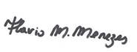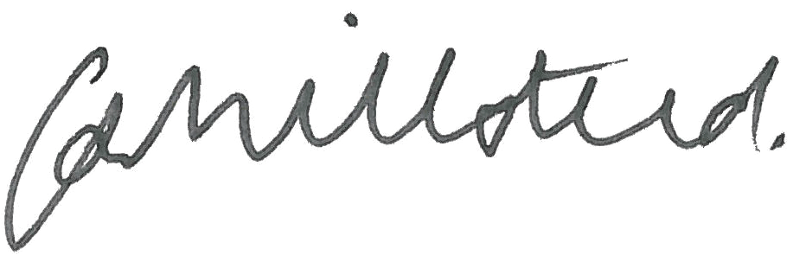
_____________________ _____________________
Chair Chief Executive Officer
F. Menezes C Millsteed
PhD U of I BEcon (Hons) BA
19 August 2021 19 August 2021

Independent auditor’s report
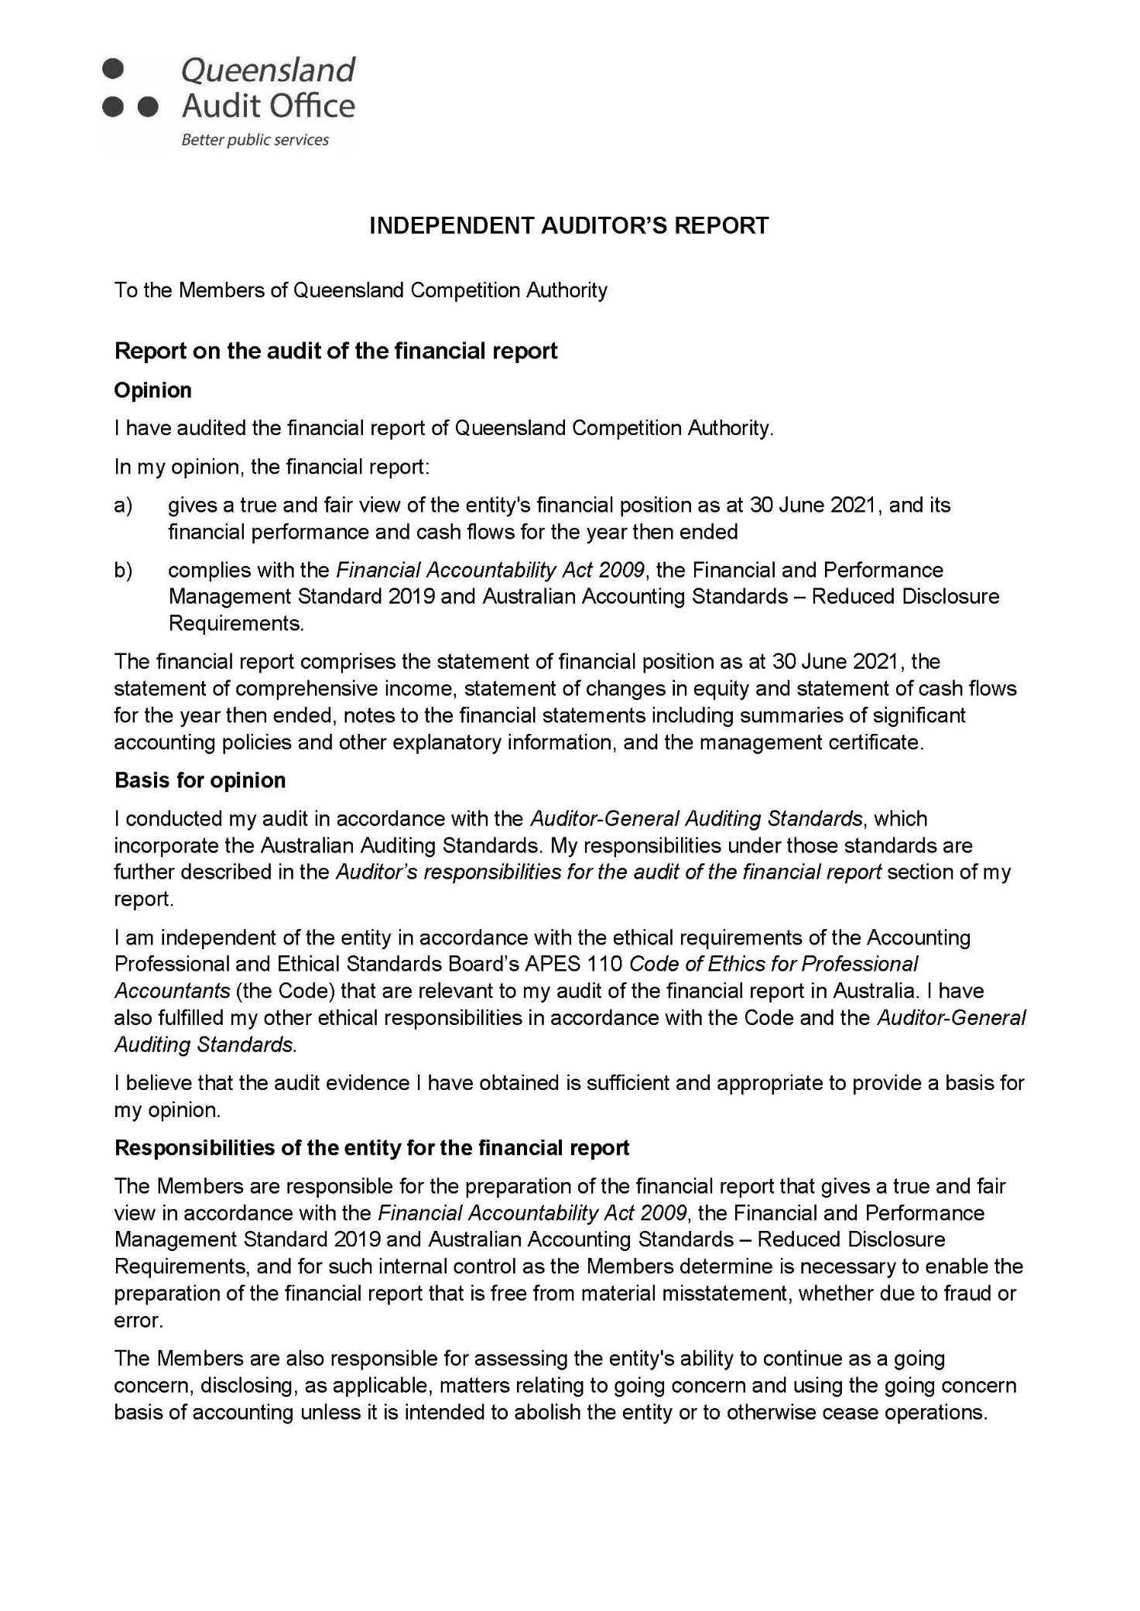

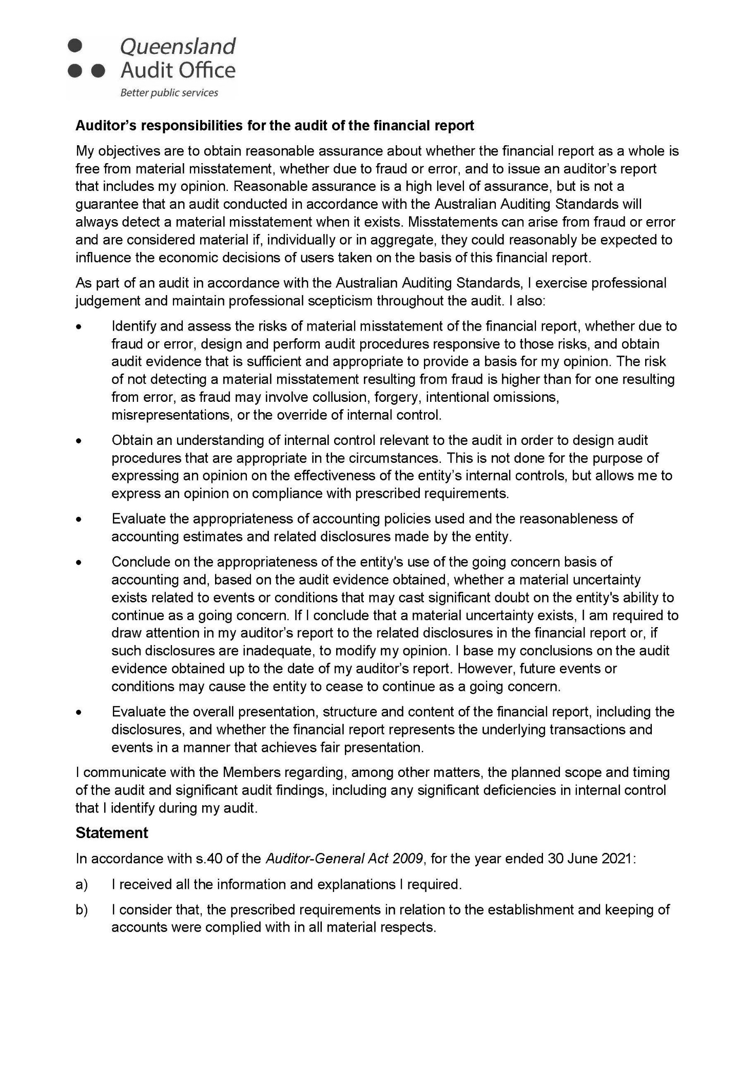

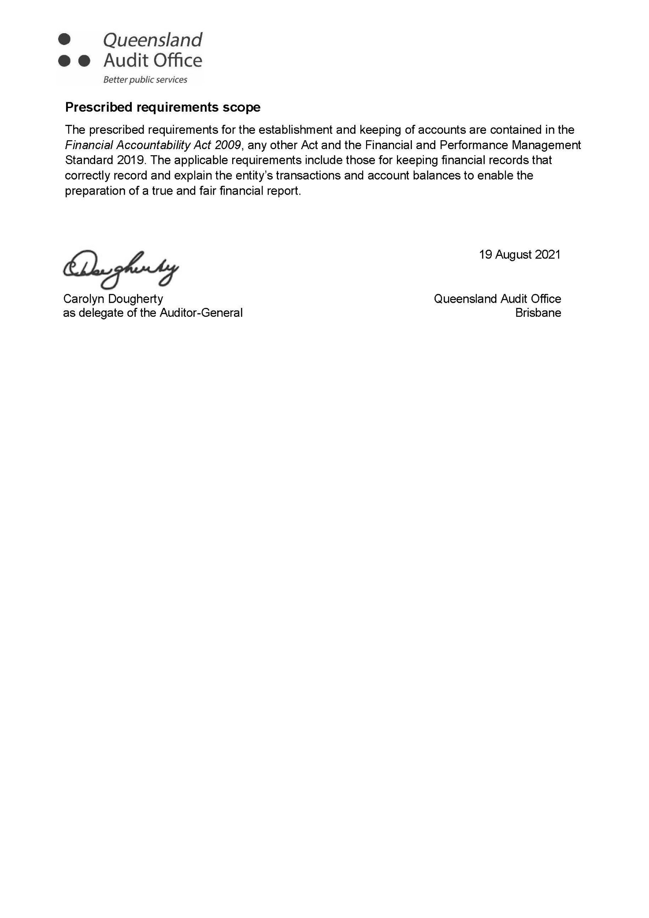

Glossary
Term | Definition
ACCC | Australian Competition and Consumer Commission
AEMC | Australian Energy Market Commission
CQCN | Central Queensland coal network
DAAU | draft amending access undertaking
DAU | draft access undertaking
DBCT | Dalrymple Bay Coal Terminal
DBIM | Dalrymple Bay Infrastructure Management Pty Ltd
Electricity Act | Electricity Act 1994
HRA | Human Rights Act 2019
IPART | Independent Pricing and Regulatory Tribunal
KPI | key performance indicator
Minister | Minister for Natural Resources, Mines and Energy
NESB | non-English-speaking background
RAB | regulated asset base
SEQ | south east Queensland
QCA | Queensland Competition Authority
QCA Act | Queensland Competition Authority Act 1997
UT5 | Aurizon Network’s 2017 access undertaking

Appendices

Appendix A: Letter of compliance
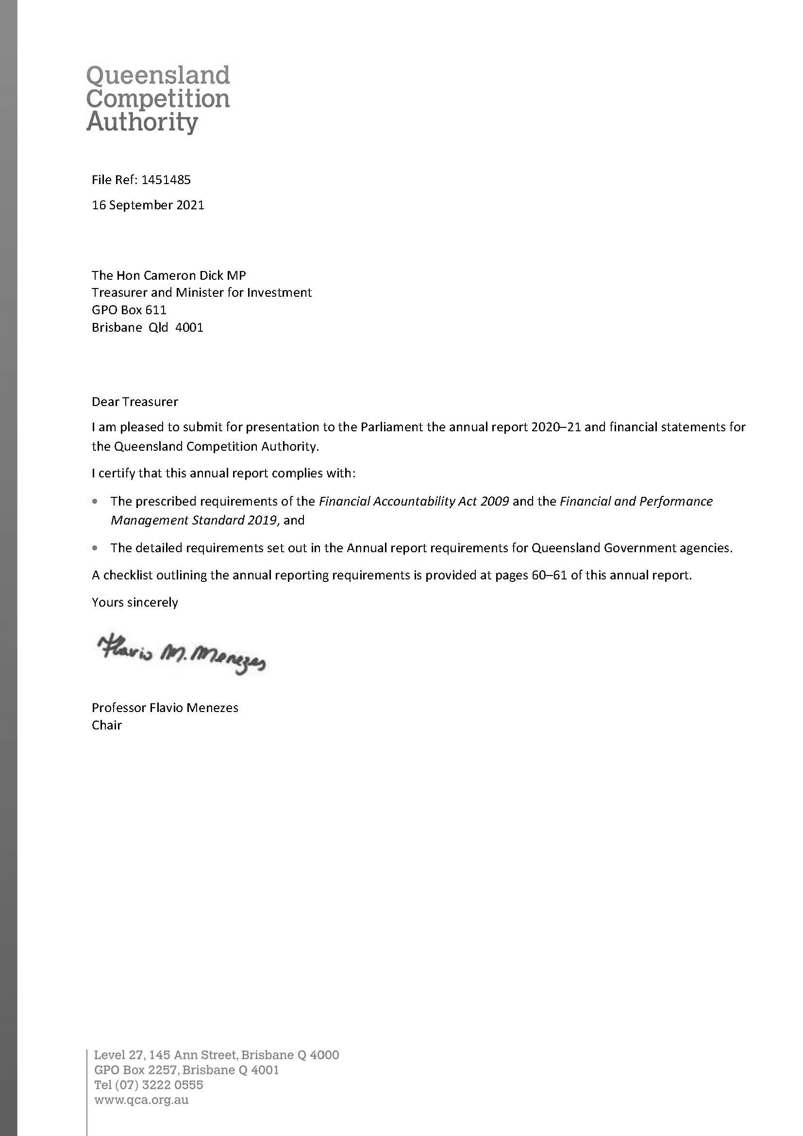

Appendix B: Compliance checklist

Summary of requirement |  | Basis for requirement | Annual report reference
Letter of compliance | - A letter of compliance from the accountable officer or statutory body to the relevant Minister/s | ARRs – section 7 | 59
Accessibility | - Table of contents  - Glossary | ARRs – section 9.1 | I  57
 | - Public availability | ARRs – section 9.2 | 62
 | - Interpreter service statement | Queensland Government Language Services Policy  ARRs – section 9.3 | 62
 | - Copyright notice | Copyright Act 1968  ARRs – section 9.4 | Back of cover page
 | - Information Licensing | QGEA – Information Licensing  ARRs – section 9.5 | N/A
General information | - Introductory Information | ARRs – section 10 | 2–3, 12
Non-financial performance | - Government’s objectives for the community and whole-of-government plans/specific initiatives | ARRs – section 11.1 | 15
 | - Agency objectives and performance indicators | ARRs – section 11.2 | 8–9, 12–31
 | - Agency service areas and service standards | ARRs – section 11.3 | 12–35
Financial performance | - Summary of financial performance | ARRs – section 12.1 | 19, 39-56
Governance – management and structure | - Organisational structure | ARRs – section 13.1 | 6
 | - Executive management | ARRs – section 13.2 | 4–5
 | - Government bodies (statutory bodies and other entities) | ARRs – section 13.3 | 7
 | - Public Sector Ethics | Public Sector Ethics Act 1994  ARRs – section 13.4 | 18, 28
 | - Human Rights | Human Rights Act 2019  ARRs – section 13.5 | 18
 | - Queensland public service values | ARRs – section 13.6 | 28
Governance – risk management and accountability | - Risk management | ARRs – section 14.1 | 18
 | - Audit committee | ARRs – section 14.2 | N/A
 | - Internal audit | ARRs – section 14.3 | 18
 | - External scrutiny | ARRs – section 14.4 | N/A
 | - Information systems and recordkeeping | ARRs – section 14.5 | 18
 | - Information Security attestation | ARRs – section 14.6 | N/A
Governance – human resources | - Strategic workforce planning and performance | ARRs – section 15.1 | 28–31
 | - Early retirement, redundancy and retrenchment | Directive No.04/18 Early Retirement, Redundancy and Retrenchment  ARRs – section 15.2 | 29
Open data | - Statement advising publication of information | ARRs – section 16 | 62
 | - Consultancies | ARRs – section 33.1 | https://data.qld.gov.au
 | - Overseas travel | ARRs – section 33.2 | https://data.qld.gov.au
 | - Queensland Language Services Policy | ARRs – section 33.3 | N/A
Financial statements | - Certification of financial statements | FAA – section 62  FPMS – sections 38, 39 and 46  ARRs – section 17.1 | 53
 | - Independent Auditor’s Report | FAA – section 62  FPMS – section 46  ARRs – section 17.2 | 54–56

FAA Financial Accountability Act 2009

FPMS Financial and Performance Management Standard 2019

ARRs Annual report requirements for Queensland Government agencies

Annual report access

Additional copies
A copy of this report can be obtained by contacting us.
email annualreport@qca.org.au
mail Executive Assistant
Queensland Competition Authority
GPO Box 2257
Brisbane Qld 4001
tel (07) 3222 0555
fax (07) 3222 0599
This report is available in PDF format
on our website: https://www.qca.org.au/our-role/

Open data
Further information on the following is available through the Queensland Government’s Open Data website, https://data.qld.gov.au
- Consultancies 2020–21
- Overseas travel 2020–21.

ISSN 1839-213X

Translating and interpreting assistance
We are committed to providing accessible services to Queenslanders from all culturally and linguistically diverse backgrounds.
If you have difficulty in understanding the annual report, you can contact us on (07) 3222 0555 and we will arrange an interpreter to assist you.

Feedback
Readers are encouraged to provide feedback
on the contents or structure of this report by contacting us at annualreport@qca.org.au

